Imperial College London

Department of Earth Science and Engineering

MSc in Environmental Data Science and Machine Learning

Independent Research Project

Final Report

**Optimising Demand Response Strategies for Carbon Intelligent Load Shifting**

By

Daniel Kaupa

*Email*: [daniel.kaupa24@imperial.ac.uk](mailto:daniel.kaupa24@imperial.ac.uk)

*GitHub username:* esemsc-dbk24

*Repository:* <https://github.com/ese-ada-lovelace-2024/irp-dbk24>

**Supervisors**:

Dr. Mirabelle Muûls

Dr. Shefali Khanna

Dr. Gareth Collins

August 29th, 2025

**ABSTRACT**

This study builds a transparent, public-data pipeline that turns grid and weather feeds into actionable, half-hourly marginal emission factors (MEFs) for India and tests whether those signals can drive real-world load shifting. Using ERA5/ERA5-Land weather and national grid data (2020–2025), we fit a penalised GAM on net load; its derivative yields a raw MEF that we linearly calibrate to short-horizon ramps and map to ramp-based confidence. Correlations are modest at small ramps and stronger ≥1 GW—good enough to steer. Midday MEFs often exceed averages, consistent with PV saturation and fossil units on the margin. A conservative greedy scheduler (±2 h; ≤1/day; ≤3/week) over ~238k customers re-times ~3.7% of energy; per-home savings are small (~6.3 kg CO₂/yr) but MEFs change accounting (+313% vs AEFs). The pipeline is reproducible and best for ranking hours, while larger gains lie upstream.

**1. INTRODUCTION**

**1.1 Background and motivation**

Electrify everything and decarbonise fast. This dual imperative of the net-zero transition combined with rising living standards, digitalisation, data centre-growth, and expanding electricity access across the Global South, is pushing an increasing amount of demand onto the grid [36]. While meeting this rising demand can require more output from conventional fossil units, falling costs and policy support are simultaneously lifting the share of wind and solar into the supply mix [31]. On average, higher renewable penetration lowers emissions, but weather- and daylight-driven variability makes the grid’s instantaneous emissions intensity more volatile. As a result, the emissions impact of electricity depends not only on how much is used, but also when it is used [4].

Recommendations for reducing grid emissions often first focus on reducing the electricity usage that causes them. The logic is sound: consume less, emit less. While this may be the most effective strategy, it encounters resistance with the comfort norms and service levels expected by customers. But the increased temporal variability of emissions intensity can offer a second, more palatable lever for customers: consume the same, but change the time of consumption to reduce emissions. In addition to the potential grid stability benefits, shifting time of usage has indeed shown promise for reducing emissions. But to evaluate the emissions reduction potential of a shift in usage, we of course need reliable emissions factors. The average emission factor (AEF) is perhaps the most familiar metric, measuring total emissions and total generation over a given geospatial and temporal range, and useful for describing systems. But when measuring the specific effects of shifting usage across time, the marginal emission factor (MEF) is the metric of choice in the literature [38].

The marginal emissions factor is the emissions rate associated with the next unit of electricity at the moment of use; the unit provided by whichever generator is setting the balance at that time. An accessible analogy is the “last-mile” of a delivery: most of the journey would happen anyway; the extra impact is in the final leg triggered by the order. Likewise, many plants run regardless of small changes in demand; the consequential impact sits with the unit that ramps up or down when consumption shifts. As weather-dependent renewables take a larger share, this rate can vary markedly across the day.

**1.2 Operational Challenges**

While the choice to use MEFs rather than AEFs is clear, there is far less agreement on how to determine these ‘last-mile’ emission rates in a way that provides reliable, high-resolution, and easily reproducible results. True MEF calculation requires extremely granular and detailed information to understand at any given point which units are online, the fuel and heat rates of those units, ramp and minimum up/down constraints, outages and maintenance, interconnector flows, transmission limits, and more. However, these data are usually proprietary to utilities and system operators, making them largely inaccessible to external stakeholders. Consequently,

those seeking to use MEFs must instead rely on estimation techniques and attempt to reconstruct grid dispatch patterns from public data feeds and the occasional (usually scope-limited) proprietary drops. These reconstructions are often laden with assumptions and specific to a particular grid region and time; as a result, they are brittle as conditions change and difficult to reproduce across geographies.

**1.3 Related Work**

Hawkes (2010) regresses the first differences of system CO2 rate on the first differences of total load using observed dispatch in Great Britain from 2002–2009 [19]. In this study, they report an average MEF of ~0.69 kg CO2/kWh (±10%) from their model with a promising R² value of 0.95. While informative, this is an observational regression, and the high correlation alone should not be read as accurate causal identification. In modern grids, coincident drivers can move emissions and load together for reasons not caused by the load change itself (e.g. solar output rising with midday demand, wind regimes shifting around the evening peak, scheduled hydro releases, interconnector flows, or must-run/nuclear constraints). Even in first-differences, those co-movements can bias the slope (sometimes severely as VRE shares grow), yielding a tight fit that reflects diurnal/seasonal patterns rather than the true marginal response to an incremental load change.

WattTime (a leading provider of marginal operating emission rates) explicitly documents why pure differencing and simple binning can be biased, and notes they abandoned difference-based models in 2014 [37]. Although their full production methodology and validation datasets are not fully public, their publications offer a useful taxonomy of methods. These include the aforementioned simple differencing across adjacent intervals, binned regressions that condition on grid “states” (hour/season/load level), experimental and quasi-experimental designs, and price/heat-rate inference to identify the marginal fuel. Their current preference emphasises hybrid models that combine grid-state–conditioned regressions fuel-specific CEMS-based intensities, and curtailment detection [38].

**1.4 Research Objectives**

This paper (and its codebase) explores the middle ground between Hawkes’ low-complexity, empirical estimation and WattTime’s hybrid, causally validated signals, and adds a practical feasibility test.

Specifically, we attempt to:

1. Retain simplicity and access: rely only on widely available public grid and weather data so the method is deployable across regions.
2. Pursue robustness with modest tooling: apply robust, lightweight statistical methods to marginal emissions estimates that remain reasonably accurate even with limited data.
3. Test practical value: develop a lightweight optimisation to identify emissions-reduction opportunities by shifting routine household use within modest time windows using these marginal signals.

The accompanying codebase produces (i) a half-hourly marginal-emissions series for India from January 2021–May 2025, and (ii) recommended household load-shift schedules for Delhi and Mumbai covering late 2021 to mid-2023, under plausible behavioural constraints and grid-aware limits.

**2. DATA**

**2.1 Data scope and sources**

This study uses public grid and weather data from 2020–2025, though only 2021–2025 are used for estimating and analysing time-varying emissions. Residential consumption covers late-2021 to mid-2023 for customers in Delhi and Mumbai.

Weather was drawn from ERA5-Land [26] and ERA5 [20]. ERA5-Land is used as the primary source with ERA5 filling gaps and adding the cloud cover variables which are not present in the ERA5-Land dataset. All variables collected are as follows: 2-meter temperature, surface net solar radiation, total cloud cover, high cloud cover, medium cloud cover, low cloud cover, total precipitation, wind speed, and wind direction. These variables are at an hourly resolution for forty-five latitude/longitude points around Delhi and Mumbai.

Grid data was taken from CarbonTracker [6], which records grid data at a five-minute resolution for all of India. This data includes total demand met, generation by source, and associated emissions.

Anonymised residential smart-meter data at half-hour resolution was provided by Tata Power through the Hitachi–Imperial collaboration and used as the basis for the scheduling proof-of-concept.

**2.2 Cleaning and processing**

ERA5-Land and ERA5 variables were harmonised to common units and names. Though ERA5-Land was primarily used when available, ERA5 was used to impute gaps. As several ERA5-Land fields are recorded as cumulative totals over the forecast period (e.g. surface solar radiation), these fields were converted (de-accumulated) to per-interval values by differencing consecutive timesteps. To place ERA5-Land and ERA5 on a common grid, variable-specific spatial re-gridding was applied. Precipitation and solar-radiation fields were remapped with conservative methods so that area-integrated totals are preserved. Temperature and wind components used bilinear interpolation, which is appropriate for smoothly varying fields. Cloud-cover variables used nearest-neighbour assignment to avoid creating spurious fractional values.

The CarbonTracker dataset required minimal cleaning, but did require gap filling. Short gaps (≤ 80 minutes) were filled using linear interpolation. Longer gaps (including multi-day outages) were reconstructed using an averaged neighbor-day gradient approach: for each missing interval we find the nearest previous and following calendar days that have data for this time slot, compute the gradients for each time slot, average them, and then apply these gradients either forward or backward based on the nearest real value available as an anchor.

**2.3 Temporal alignment**

All sources were aligned to a half-hourly grid in India Standard Time (IST) to match the meter data.

ERA5/ERA5-Land was resampled to 30-minute resolution: temperature and wind speed via linear midpoint interpolation; cloud cover via linear midpoint with values clamped to [0,1]; wind direction via speed-weighted circular interpolation; precipitation by evenly splitting hourly totals; and solar radiation with an energy-conserving, ramp-aware split (sunrise/sunset shoulders shaped; half-hour values sum to the original hourly totals; daily integrals preserved). Static fields were carried forward from the current hour.

CarbonTracker reports five-minute data with start-of-interval timestamps (e.g., 09:55 represents 09:55–10:00), whereas meter data are traditionally end-of-interval [13, 29]. To align conventions, we first shifted the grid series to interval-end. We then aggregated to half-hour intervals: rate variables (generation by source, demand met, average intensity) were averaged within each half-hour, and totals (t CO₂) were summed. Final timestamps were snapped to :00 and :30, yielding half-hour series that align exactly with the consumption data and with the emissions estimates used later.

**2.4 Feature construction for modelling**

All plausible drivers were first engineered into modelling-ready predictors using consistent transformations across demand, generation by source, weather, and time. From this full set, variables were then selected empirically by screening for low collinearity (pairwise correlations and variance-inflation checks) and by keeping those that improved fit and stability in the level model while preserving a smooth, well-behaved derivative. The final specification reflects that testing and prioritises transparency and portability. The exact selection may vary by grid and data quality (see results section), and substitutes are straightforward where a given feature is weak or unavailable.

*Net load (demand_minus_renewables → demand_minus_renewables_std).*

Net load is total demand minus non-dispatchable renewable generation (solar and wind in our dataset) and approximates the residual demand that dispatchable (usually thermal) units must cover. In most hours, renewables do not set the marginal unit; fossil generators do, so modeling against net load is preferred to capture driver of operational emissions [7, 11]. We standardise it (zero mean, unit variance) so the smoother operates on a stable scale and the derivative (our marginal signal) is numerically well behaved.

*Weather smooths (temperature_celsius_std, wind_speed_mps_std, surface_net_solar_radiation_kWh_per_m2_log1p_std).*

Temperature and wind speed affect both demand and supply. We standardise them so penalties treat each on a comparable scale. Solar irradiance is heavy-tailed and spikes around midday; applying a log-transform (log1p) compresses those tails and reduces leverage from a few very bright hours. These three variables enter as smooth functions so the model can learn non-linear responses (for example, rising emissions on very hot evenings when cooling demand surges).

*Wind direction context (wind_dir_sin, wind_dir_cos).*

Wind direction is encoded with sine and cosine to avoid artificial jumps at 360/0 and allow the model to “fully capture the circular characteristics” as stated by Bentsen et. all [3].

*Generation context (hydro_share_std).*

Instead of using raw generation by fuel, we model the generation mix with fuel shares. Raw outputs co-move strongly with total demand, inflating collinearity. Though shares increase variance inflation factor scores amongst themselves, they reduce the VIF score against demand. Additionally, shares naturally encode relative mix as the sum of shares equals 1. All shares were standardized, and hydro retained as it consistently improved the rank-order accuracy without meaningfully sacrificing $R^{2}$.

*Sky condition indicator (is_sunny).*

A simple flag was derived from irradiance greater than 0 to separate daytime from nighttime conditions. This provides a regime switch that helps the model avoid attributing solar-driven swings to demand alone.

*Time structure (hour_sin, hour_cos, doy_sin, doy_cos, is_weekend).*

Daily and seasonal patterns are smooth and periodic. We encode hour-of-day and day-of-year with sine/cosine pairs to respect their circular structure, so 23:30→00:00 and 31 Dec→1 Jan are treated as adjacent. This avoids edge discontinuities and the need for many dummy variables. A weekend indicator captures systematic behavioural shifts (e.g., later evening peaks).

**2.5 Data availability and reproducibility**

All weather inputs are publicly available. ERA5-Land and ERA5 can be accessed without charge, and the workflow is portable to other public sources that expose similar variables and metadata. For example, Open-Meteo [28] provides access to similar variables that could be used to suitable for reproducing the feature set where ERA5 access is constrained.

For electricity and emissions, CarbonTracker provides the India-wide signals used here. The approach is intentionally portable because analogous feeds exist in other regions in near-identical formats: Electricity Maps (multi-region) [14], the UK Energy Dashboard [16], the International Energy Agency (IEA) global datasets [15], and the US Energy Information Administration (EIA) series for the United States [12]. Substituting any of these sources requires only minor renaming and unit checks, as the analysis operates on standard quantities (demand met, generation by source, and emissions or emission factors) at hourly or sub-hourly resolution.

Household consumption data (Delhi and Mumbai) were provided under agreement by Tata Power through the Hitachi–Imperial collaboration. These data are not public; however, the optimisation component depends only on a generic half-hourly load profile and thus remains reproducible with any comparable smart-meter dataset.

**3. METHODS: Estimating marginal emissions**

**3.1 Objective and design**

Our aim is twofold. First, to fit a national-level model that explains half-hourly system CO2 as a smooth function of net load and weather/time covariates. Second, to obtain a time-varying marginal signal by taking the partial derivative of the fitted mapping with respect to net load, evaluated at the observed covariates. The result yields a national marginal emissions series suitable for operational guidance.

**3.2 Candidate approaches**

Work began from a binned-regression template [1]: observations were stratified by local weather (solar irradiance, wind speed), then emissions (tCO2) were regressed on demand (MW) and demand2, with hour and month fixed. Despite a high level-model $R^{2}$, the rank correlation with short-horizon slopes was modest.

We then engineered a richer, low-collinearity feature set (§2.4), ran ablations to isolate key drivers (see Appendix C – Tables M1 -M4), and tested Polynomial ridge , Huber regression, Groupwise OLS, and a penalised generalised additive model, using bootstrap checks for stability. The results (see §5.1 and Appendix C -Tables M5 and M7) pointed toward a model that is flexible where needed, yet penalised enough to keep the derivative smooth.

**3.3 Final Estimator**

We adopt a penalised generalised additive model (pyGAM) to model half-hourly CO2 emissions. The model uses smooth functions of standardised net load , temperature, wind speed, and log-compressed solar radiation (denoted Q, T, W, S), plus linear context terms of wind direction (sin/cos), hydro-generation share, Fourier time controls (hour and day-of-year sin/cos), a weekend flag, and a sunny/not sunny flag. This model can be described in the following equation:

$Y=β_{0} + f_{Q}\left(Q_{std}\right) + f_{T}\left(T_{std}\right) + f_{W}\left(W_{std}\right) + f_{S}\left(log{\left(1+S_{raw}\right)}_{std}\right) + x _{lin }^{⊺}β + ε$.

Each $f(∙)$ ​ is a spline learned jointly with the others by penalised least squares. We use an $L2$ curvature penalty (a penalty on the integrated second derivative ( $\int{{(f^{''}(u))}^{2}du }$), which balances the fit of the model to the data with smoothness of the curve. This regularisation helps prevent overfitting and stabilises the first derivative $∂\hat{Y}/∂Q$, which we interpret as the marginal emissions signal. The final model set 20 basis functions (splines) per smooth and set the penalty ($λ$) to 50 for each smooth. These settings were chosen via a small grid search that prioritised maximising marginal-signal alignment (Pearson/Spearman) with only minor trade-offs in level $R^{2}$.

**3.4 From levels to marginal effects**

After fitting the level model, the marginal series is the partial derivative of the fitted value with respect to raw net load, holding all other covariates at their observed values:

$\hat{ME_{t}} =\frac{∂\hat{Y}}{∂Q_{raw}}{ |}_{Q=Q_{t} , X = X_{t}}$.

Because the model is trained on the standardised net load $Q_{std} = \frac{Q_{raw }- μ_{Q}}{σ_{Q}}$, we must also undo the scaling via the chain rule:

$$\frac{∂\hat{Y}}{∂Q_{raw}} = \frac{1}{σ_{Q}} \frac{∂\hat{Y}}{∂Q_{std}} .$$

**3.5 Validation and calibration**

After the model provides expected half-hourly CO2, and the derivative $∂\hat{Y}/∂Q$ yields the marginal signal, we can then evaluate whether the marginal signal produced matches the actual changes experienced by the system. To perform this evaluation, we construct ramp-pairs: consecutive half hour periods between t and t+1; and then compute the empirical slope ($s_{i}$) and the midpoint of the marginal estimate (${ME}_{i}^{mid}$):

$s_{i} = \frac{ΔY}{ΔQ} = \frac{Y_{t+1} - Y_{t}}{Q_{t+1} - Q_{t}} , {ME}_{i}^{mid} = \frac{1}{2} ({\hat{ME}}_{t }+{\hat{ME}}_{t +1 })$.

To measure how close our estimates are to the observed change, we can fit a simple linear model:

$s_{i} = a + b{ME}_{i}^{mid} + ε_{i}$.

If the model’s marginal signal were perfectly scaled and unbiased, we would have ${a ≈ 0 and b ≈ 1 so that s}_{i} ≈ {ME}_{i}^{mid}$. Since our model produced $a ≈ -0.6 and b ≈ 2.2$ (varying across ramp sizes $∆Q$) calibration was needed. To determine which ramp size to use for our final calibration coefficients, we ran a sweep of ramp size thresholds on the validation set. At each threshold, the linear model described above was fit with weighted least squares (weights being ramp sizes). The configuration with the highest $R^{2}$ (0.29) and lowest RMSE at $∆Q≈ 4,255$ MW yielded $\hat{a}= -0.583 and \hat{b}=2.226$. Finally, we then apply the transformation to the entire series, adjusting each value by the fitted intercept and slope:

$${\hat{ME}}_{cal} = \hat{a} + \hat{b}\hat{ME}$$

Note that while this step will not change or improve the association as measured by the Pearson and Spearman correlations, it significantly reduces unit error by moving the OLS slopes towards 1.0 and the intercepts towards 0.0.

**3.6 Confidence Labels and Measure Consolidation**

To make the series usable with the raw meter-readings, we make two final adjustments. First, we attach a confidence label to each timestamp based on the out-of-sample ramp-pair Pearson r correlation in its ∣ΔQ∣ band: r < 0.40 → “low”; 0.40 ≤ r < 0.60 → “medium”; r ≥ 0.60→ “high” (none occur in our data). In analysis, these labels help identify whether any proposed shifts are using predictions with low or medium confidence in their directional accuracy. The second adjustment we make is a unit conversion from tons CO₂ per MW per 30-min to grams CO₂ per kWh to match the meter data. Since 1 MW sustained for 30 min equals 0.5 MWh, we multiply the ${\hat{ME}}_{cal}$ value by 2,000 to make this adjustment.

**4. METHODS: Emissions‑Aware Load Shifting**

**4.1 Objective and solver choice**

With a marginal emissions factor available for each half-hour, the next task was to build an optimiser that checks whether emissions savings are possible on a given day and identifies concrete shifts to realise them.

We prototyped three approaches in parallel: a continuous relaxer, a windowed linear program (LP), and a greedy scheduler, but we report results here for the greedy method only. Greedy was the first to succeed in development, runs quickly, has minimal dependencies, and proved robust across shards. While LP/continuous formulations can reach globally optimal allocations (whereas greedy is local), they were costlier to set up and debug within project timelines. Given the goal of a lightweight, reproducible tool, greedy is the main model profiled here.

**4.2 Greedy scheduler: idea and core equation**

A greedy search heuristic makes the single best feasible move available, updates all limits, and repeats until no improving move remains. In our setting, a “move” reallocates $q_{i,t →s}$ kWh from a higher-MEF slot $t$ to a lower-MEF slot $s$ within a short time window $| t → s| ≤ W$. The model for this scheduler can be written as a minimisation or an equivalent maximisation problem:

$$\min_{q ≥ 0}{\sum_{i ∈ I }{\sum_{t}{\sum_{s}{m_{s}q_{i,t → s }}}}} or \max_{q≥0}{\sum_{i ∈ I}{\sum_{t}{\sum_{s}{{(m}_{t} - m_{s})q_{i,t →s}}}}}$$

where $i ∈ I$ indexes customers (households), $t,s ∈ T = \{0,...,47\}$ index half-hour slots in a day with $t$ as the source time slot and $s$ as the destination time slot, and $m_{s or t}$ is the marginal emission factor at that slot in grams CO2/kWh. This project implements the maximisation view by at each step, scoring every feasible local move (t $→$ s) by $∆{CO}_{2} = (m_{t} - m_{s}) × q_{max }$, executing the best move, updating caps, and repeating until no improving move remains. These moves are also subject to constraints, described in the next section.

**4.3 Constraints**

To make the implementation more applicable to real world use cases, the search is restricted to operational and comfort limits. Perhaps the most important constraint is the conservation of energy constraint which enforces that each customer still uses the same amount of energy, but just moves the time of usage. This energy is restricted to each household and within each 24-hour period. The equation for this constraint can be written as a combination of slot level conservation:

$$\underset{after}{\underbrace{x_{i, t}}} = \underset{before}{\underbrace{u_{i, t}}} - \sum_{\underset{\underset{outflow from t}{\underbrace{s ≠ t, |t-s| ≤ W}}}{\underbrace{s ∈ T}}}{q_{i,t→s} }+ \sum_{\underset{\underset{inflow into t}{\underbrace{r ≠ t, |r-t| ≤ W}}}{\underbrace{r ∈ T}}}{q_{i,r→t} with x_{i,t }≥ 0, ∀i∈I, t ∈T}$$

and daily conservation:

$$\sum_{t∈T}{x_{i,t} }=\sum_{t∈T}{u_{i,t} } with ∀i∈I ,$$

where $u_{i,t}$ is the original energy use in kWh for the customer $i$ in slot $t$ before any shifting, $x_{i,t}$ is the post-shift energy use for customer $i$ in slot $t$ after the optimisers moves, and $r$ is a dummy time slot index for inbound flows.

The rest of the constraints implemented are illustrated in Table 1 below, and full equations are documented in the appendix. It is important to note the values below are used in the main experiment, but they could be modified to test alternative policies.

|  |  |  |
| --- | --- | --- |
| **Constraint** | **Description** | **Value used** |
| Maximum Shift Time Window | Limit the time window for each shift to avoid excessive disruption | ±2 hours |
| Maximum Shifts per Customer per Day | Limit number of slot shifts per customer in a day to avoid significant disruption to their routine | 1 |
| Maximum Shifts per Customer per Week | Limit number of slot shifts per customer for a week to avoid significant disruption to their routine | 3 |
| Maximum Shift out of Peak Hours | Limit shifts that move usage out of peak hours to avoid disruption to routine | ≤ 25% of baseline in peak hours |
| City destination anti-spike | Avoid crowding a single city half-hour | ≤ 25% uplift vs baseline |
| Maximum Regional Shift Percentage per Day | Limit the maximum percentage of a region's total load that can be shifted in a day (city-scale) | ≤ 10% of daily city load |
| Minimum Usage per Slot | Ensure a minimum level of usage in each time slot to represent always-on loads in a household | max{hour-of-day/day-of-week minimum, 10% × robust maximum, ε} |

**Table 1: Optimiser Constraints**

**5 . RESULTS**

**5.1 Model Scores**

Although Ridge/Huber/OLS polynomials achieved slightly higher level fit (R2) than GAM , that metric is insufficient for our purpose because marginal emissions (ME) = derivative of the level model. High R² does not guarantee a stable or well-scaled derivative. We therefore evaluate models on ramp-pair metrics: Pearson (linear agreement between predicted ME and realized slope ΔY/ΔQ) and Spearman (rank ordering) [statstutor.ac.uk]. On 30-min pairs with |ΔQ|≥100 MW, GAM delivers the most reliable ME signal (highest Pearson, comparable Spearman) with only a small trade-off in level R², so we select GAM as the production model.

|  |  |  |  |  |  |
| --- | --- | --- | --- | --- | --- |
| **Model Family** | **R2** | **RMSE** | **MAE** | **Pearson** | **Spearman** |
| PyGAM | 0.9840 | 754.7759 | 607.8375 | 0.20034 | 0.43128 |
| OLS | 0.9866 | 690.2669 | 520.8337 | 0.19631 | 0.44248 |
| Median | 0.8628 | 2137.5000 | 1861.5000 | 0.19100 | 0.41400 |
| Quantile | 0.9366 | 1487.9000 | 1253.1000 | 0.18600 | 0.48200 |
| Huber | 0.9863 | 697.4679 | 526.2785 | 0.17774 | 0.41410 |
| Ridge | 0.9866 | 690.6372 | 521.7645 | 0.17766 | 0.41352 |

**Table 2: Model Comparison**

See Appendix C – Table M5 for full results

**5.2 Influence of Ramp Size**

The GAM’s marginal signal strengthens as ramp magnitude grows. On validation the correlation between our predicted marginal emissions $\hat{ME}$ and realised slopes $s = ∆Y/∆Q$ rises with |∆Q|: small ramps (~P10) give Pearson $r ≈ 0.36$, Spearman $ρ ≈ 0.46$; around the median ramp (|∆Q| = 2,330 MW) $r ≈ 0.53, ρ ≈ 0.56$. See the figures below for illustration.

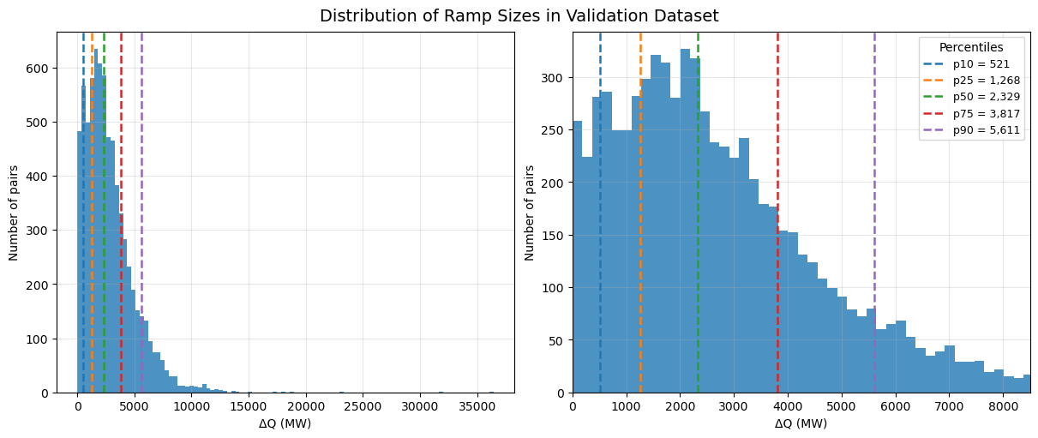

**Figure 1: Ramp Sizes Distribution**

See Appendix D – Figures M1-3 for full results

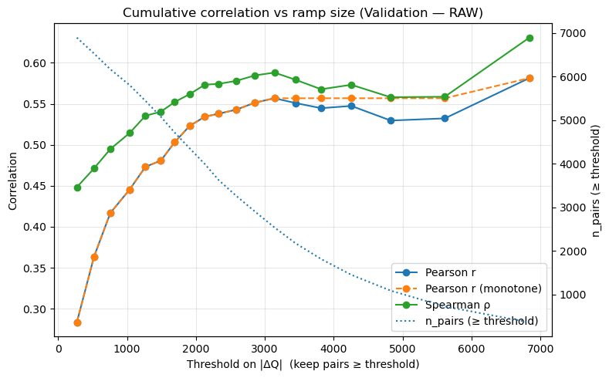

**Figure 2: Correlation and Ramp Sizes**

See Appendix D – Figures M4 and M5 for full results

**5.3 Unit Alignment**

Even with good correlation, raw ME magnitudes were under-scaled: regressing 𝑠 on $\hat{ME}$ over validation yielded slopes > 1 and a small negative intercept. We therefore fit a single linear calibration on validation pairs (weighted by ∣ΔQ∣) in the operationally strong ramp region (≈P80–P90, ∣ΔQ∣≈4.255 GW). This yielded a≈−0.58, b≈2.23, and after applying this calibration to the dataset, the OLS line moves near the identity (slope ≈ 1, intercept ≈ 0) across ramp bins, and distance metrics improve materially (see Appendix C – Tables M8-9). The figure below illustrates how the data transforms, and it is important to note the Spearman value is unchanged after this alignment as it is a simple linear transformation that makes the $\hat{ME}$ more directly interpretable.

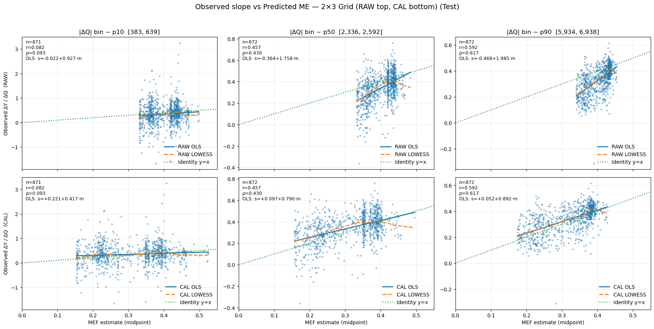

**Figure 3: Calibration of Estimates**

See Appendix D – Figures M6-10 for full results

**5.4 Confidence Labels**

To translate the diagnostics into user-facing guidance, we assign confidence to each timestamp based on the expected Pearson r at its ramp magnitude (estimated from the validation curves). Ramps with Pearson scores below 0.4 are assigned ‘low’ confidence and those between 0.4 and 0.6 are assigned ‘medium’ confidence. No scores above 0.6 were observed to justify a ‘high’ confidence band. These cut points are more conservative than the widely used correlation effect-size conventions (small/medium/large around 0.1/0.3/0.5 [8], but still manage to capture most of our timestamps as shown in figure 4 below.

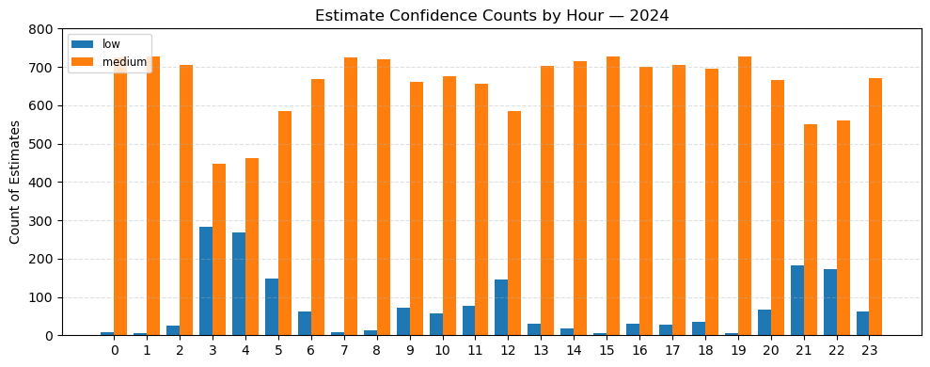

**Figure 4: Confidence Bands of Emissions Estimates**

See Appendix D – Figures M15-16, and Appendix C – Table O5 for more detail

**5.5 Distribution of marginal factors over time**

Year-by-year distributions of calibrated ME show a widening range from 2021→2025. Median ME drifts modestly down (consistent with cleaner energy), but the spread increases, reflecting a more variable system as solar/wind penetration rises. This is expected: average emissions can fall even as marginal emissions become more volatile if low-carbon supply saturates during certain hours and fossil units set the margin for increments/decrements [34].

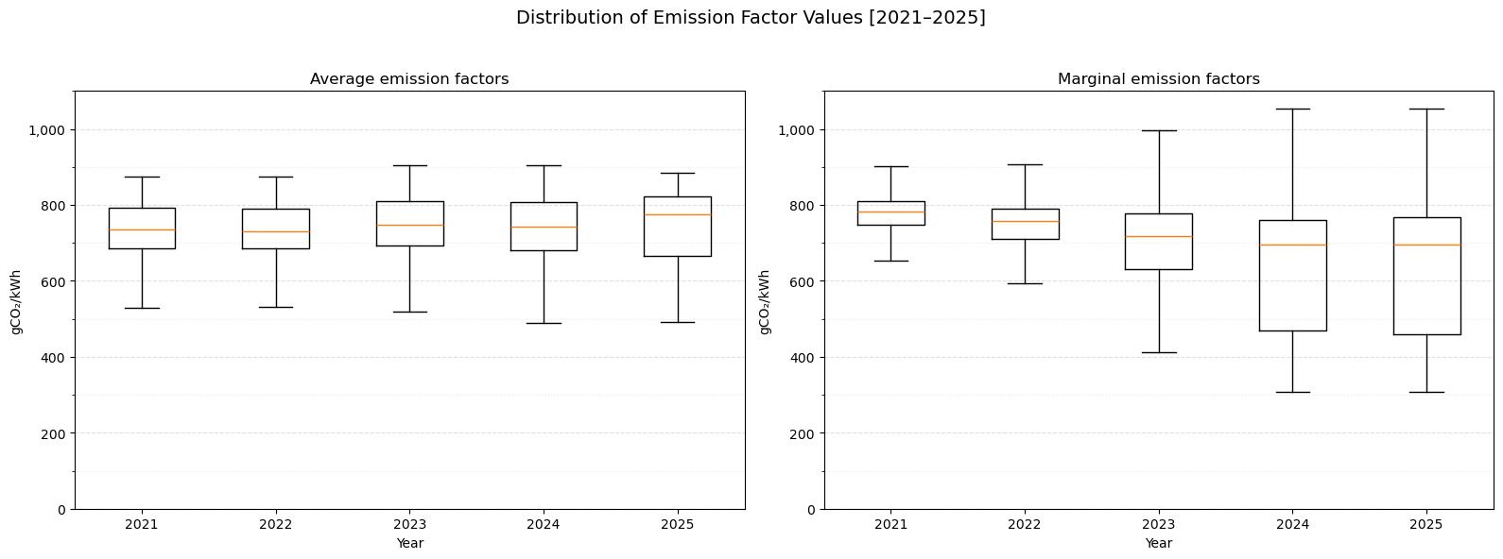

**Figure 5: Boxplot Distribution of Emission Factors, 2021-2025**

See Appendix D – Figures M12-14 and S8-11 and Appendix C – Table S1 and S2 for more detail

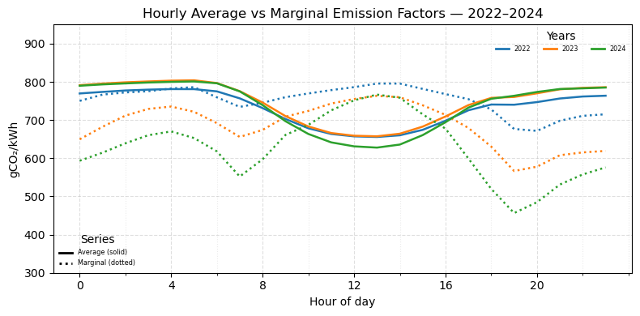

**Figure 6: Hourly Marginal (calibrated) and Average Emission Factors, 2022-2024**

**5.6 Scheduler outcomes (household vs aggregate)**

The scheduler respected conservative behavioral and technical constraints, but the results were not groundbreaking. Per-household impact is small. The average action moved about 0.40 kWh (roughly one efficient laundry cycle or several kettle boils [10, 21], so the annual avoided CO₂ per home is only a fraction of a percent of a typical household footprint. Illustrative stats below (all shifts, 30-min slots):

|  |  |  |  |  |  |
| --- | --- | --- | --- | --- | --- |
| **Region** | **Move Count** | **Average CO2 per move (g)** | **Median CO2 per move (g)** | **Average kWh per move** | **Median kWh per move** |
| All | 14,996,536 | 44.1995 | 26.1329 | 0.4286 | 0.3230 |
| Delhi | 12,394,970 | 44.3293 | 25.9728 | 0.4191 | 0.3185 |
| Mumbai | 2,601,566 | 43.5812 | 26.7853 | 0.4738 | 0.3425 |

**Table 3: Shifts and Savings by Region**

See Appendix C – Table O4-7 for full results

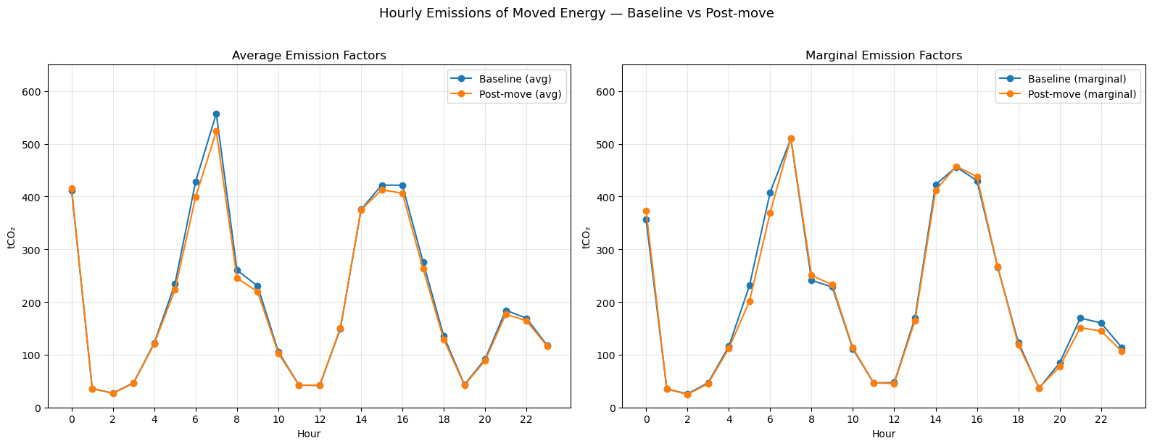

**Figure 7: Hourly Emissions Profile pre- and post-Optimisation Moves**

See Appendix D – Figure O1 and Appendix C – Tables O4-9 for more detail

Though no extreme opportunities for savings were uncovered, comparisons of the same household schedule with emissions calculated with average emission factors versus calibrated marginal emission factors highlighted the differences between the two. Where AEF-based calculations yielded savings of 160 t CO2, MEF-based calculations yielded 663 t CO2, 313% higher. See Appendix C - Table O9.

**6. DISCUSSION**

**6.1 Interpreting the varying MEFs**

A persistent feature of the results is higher MEFs than AEFs at midday/early-afternoon, even as AEFs dip (Figure 6). A plausible explanation is renewable saturation: PV (and some wind) already run near their instantaneous limits in these hours, so incremental load is met by coal/gas units with higher marginal rates; unit-commitment and ramp limits amplify this effect [33]. Hydro share enters as a consistent (likely negative) predictor of marginal CO₂ across model families. We interpret this as an association rather than causation: India’s reservoir hydro is dispatchable and its operation (releases/peaking) likely co-moves with ramps, renewable availability, and seasonal inflows [22, 24, 27]. But without plant-level dispatch or reservoir data, we cannot identify the causal pathway. The literature is mixed on whether MEFs are typically above or below AEFs, with outcomes depending on fuel mix and operating regime [19, 34]. India’s coal-heavy system with fast-growing solar fits squarely within those mixed findings.

Year-by-year, the calibrated MEF distribution widens from 2021→2025, while its median drifts modestly down (Figure 5) i.e., cleaner on average yet more variable at the margin as renewables saturate in some hours and fossil units set the incremental response—exactly what MEFs are meant to capture.

**6.2 Pearson, Spearman, and calibration**

R² alone isn’t sufficient for our purpose because MEF is the derivative of the level model—great level fit can still yield a noisy or mis-scaled derivative. We therefore evaluate on ramp-pair diagnostics: Spearman (do we rank ramps correctly?) and Pearson (do magnitudes line up?). Ramp size matters: on validation, small ramps (~P10) give r≈0.36, ρ≈0.46; around the median (|ΔQ|≈2.3 GW) r≈0.53, ρ≈0.56; top-decile ramps (≳5.6 GW) reach ~0.5–0.6. Raw ME was systematically under-scaled: regressing realized slopes (ΔY/ΔQ) on ME yielded slopes >1 and a small negative intercept. A simple linear calibration on validation pairs (WLS, weight |ΔQ|, using the P80–P90 ramp region) produced a≈−0.58 and b≈2.23; applying s_cal = a + b·ME moves the fit close to the identity line (slope≈1, intercept≈0) and improves distance metrics. Because calibration is linear, Spearman is unchanged; the goal is unit alignment, not re-ranking.

**6.3 Practical implications (households and. system)**

With conservative behavioral/technical constraints, per-home impact is small. The average action shifted ~0.40 kWh (roughly one efficient laundry cycle or several kettle boils), so annual avoided CO₂ per home is <1% of a typical footprint (Appendix C – Table O8). This is not a compelling standalone lever unless there are regulatory programs where every kilogram counts. We also note most chosen moves were ≥ 90 minutes from the original slot (within the ±2 h window), suggesting the algorithm consistently found cleaner windows just beyond the immediate neighborhood.

Even when per-home gains are small, MEF-aware scheduling remains informative at scale and for program design (when to ask, whom to target, how aggressively to relax constraints for opt-in cohorts). Additionally, using calibrated MEFs instead of AEFs changes the arithmetic: on the same schedule, MEF-based avoided CO₂ was +313% relative to AEF-based calculation (Appendix C – Table O9). Depending on the emission factor used, you can severely under- or over-state impact.

**6.4 Limits and Next Steps**

We kept the method lean and auditable by design, which brings clear limits: weather inputs come from two metros while the target is national (blurring local dynamics, especially on small ramps); utility operations we don’t observe (outages, curtailment, imports/exports, fuel constraints) add noise; a single linear calibration aligns units but can’t fix structural bias; and the greedy scheduler is transparent but not globally optimal—regional caps didn’t bind here because we modeled a subset of customers, so a real roll-out must couple to true system caps to avoid crowding. Next steps could include: adding richer utility signals and broader weather coverage; allowing varying-coefficient effects (e.g., ME varying with hydro), plus holiday/heat-wave flags and light day-ahead forecasts; replacing the greedy heuristic with a globally aware solver (with fairness/crowding controls) and testing wider opt-in shift windows; and validating externally against third-party MEFs.

**6.5 Takeaways**

The calibrated GAM provides a directionally correct, operationally useful MEF signal. It tracks short-horizon system movements, ranks hours reliably (especially at normal-to-large ramps), and—after a simple calibration—expresses marginal effects in usable units. It’s best used to prioritize hours and guide small shifts, not as a substitute for operator-grade inventories. The midday finding (MEF > AEF while AEF dips) is plausible in a coal-heavy system with growing solar and aligns with prior evidence. Given today’s constraints, bigger wins likely lie upstream—hydro dispatch, transmission, curtailment reduction, and commitment strategies that minimize marginal, not just average, emissions.

**7. CONCLUSION**

We set out to turn public grid and weather data into actionable guidance. The work delivers (i) a portable estimator whose derivative with respect to net load serves as a robust marginal-emissions (MEF) signal, (ii) a simple linear calibration that aligns that derivative to realized short-horizon changes, and (iii) a constraint-aware scheduler that translates the signal into small, acceptable household shifts. A GAM produced the most reliable MEF for operational ramps; correlations strengthen with ramp size, and calibration corrected scale without changing ranks. Ramp-based confidence labels make reliability explicit—most hours fall in the medium band—so the series is best for ranking rather than meter-grade accounting. Midday MEFs often exceed AEFs even as AEFs dip, and the MEF distribution widens from 2021–2025 while medians drift down.

Operationally, per-home effects are small under conservative constraints (~0.4 kWh moves within ±2 h), but the scheduler consistently finds cleaner windows, and using MEFs instead of AEFs materially changes avoided-CO₂ (+313% on the same schedule). Bigger gains likely sit upstream—hydro dispatch, curtailment reduction, transmission, and commitment strategy. The framework is clear, reproducible, and portable; with regionalisation, utility signals, and day-ahead forecasts, it can scale while remaining auditable.

**REFERENCES**

[1] Aditya Tomar. (2024). *margE_India.Rmd* [R]. Imperial College London. <https://github.com/ese-ada-lovelace-2024/irp-dbk24/blob/main/emission_rate_methodologies/marginal%20emissions/margE_India.Rmd>

[2] Ajay Shankar, A K Saxena, & Taruna Idnani. (2025). *Roadmap to India’s 2030 Decarbonization Target*. The Energy and Resources Institute. <https://www.energy-transitions.org/publications/roadmap-to-indias-2030-decarbonization-target/>

[3] Bentsen, L. Ø., Warakagoda, N. D., Stenbro, R., & Engelstad, P. (2023). Spatio-temporal wind speed forecasting using graph networks and novel Transformer architectures. *Applied Energy, 333*, 120565. <https://doi.org/10.1016/j.apenergy.2022.120565>

[4] Bracht, F., Khanna, S., Martin, R., & Muûls, M. (2025). *Waiting for carbon reductions—A smart IV approach*.

[5] Buchholz, K. (2022, November 9). *Infographic: India’s Electricity Mix*. Statista Daily Data. https://www.statista.com/chart/27963/india-energy-mix

[6] Center for Social and Economic Progress. (2020, September 22). *The CSEP Electricity and Carbon Tracker.* CSEP Electricity and Carbon Tracker. <https://carbontracker.in/> (Accessed on 14-07-2025)

[7] Clean Energy Buyers Institute. (2022). *GUIDE TO SOURCING MARGINAL EMISSIONS FACTOR DATA* (Next Generation Carbon-Free Electricity Procurement Activation Guide) Clean Energy Buyers Institute. <https://cebi.org/wp-content/uploads/2022/11/Guide-to-Sourcing-Marginal-Emissions-Factor-Data.pdf>

[8] Cohen, J. (2013). *Statistical Power Analysis for the Behavioral Sciences* (2nd edn). Routledge. https://doi.org/10.4324/9780203771587

[9] Council on Foreign Relations. (2024, December 5). *How Electrification Can Reduce Emissions*. CFR Education from the Council on Foreign Relations. <https://education.cfr.org/learn/reading/electrification-climate-change>

[10] Dhesi, Ben (2023, January 18). *How much does it cost to boil a kettle?*. Hugo. <https://hugoenergyapp.co.uk/cost-to-boil-a-kettle/>

[11] EIA. (2023, June 21). *As solar capacity grows, duck curves are getting deeper in California—U.S. Energy Information Administration* (EIA) [Governmental]. Today in Energy. <https://www.eia.gov/todayinenergy/detail.php?id=56880>

[12] EIA. (n.d.). *Hourly Electric Grid Monitor: U.S. Electricity Overview (U.S. Lower 48)* [Governmental]. U.S. Energy Information Administrtion Independen Statistics and Analysis. Retrieved 27 August 2025, from <https://www.eia.gov/electricity/gridmonitor/index.php>

[13] Elecenergy. (2013). *Interval Energy Data, or Itemized Energy Data?: Understanding the Benefits of Analyzing & Improving a Buildings Energy Usage & Cost Profile using one or both techniques*. <https://elecenergy.co.uk/assets/white-paper-interval-energy-data-or-itemized-energy-data.pdf>

[14] ElectricityMaps. (2025). *Carbon Intensity* (Versions 2025-01-27) [Dataset]. https://github.com/electricitymaps/electricitymaps-contrib/tree/master. <https://www.electricitymaps.com>

[15] IEA. (2025, August 13). *Real-Time Electricity Tracker – Data Tools—IEA*. Real-Time Electricity Tracker. https://www.iea.org/data-and-statistics/data-tools/real-time-electricity-tracker?from=2025-7-23&to=2025-8-22&category=demand

[16] Energy Dashboard. (2025, August 12). *Live Generation, Demand and Emissions*. Live UK Electricity Generation, Carbon Intensity & Demand – Energy Dashboard. <https://www.energydashboard.co.uk/live>

[17] Fleschutz, M., Bohlayer, M., Braun, M., & Murphy, M. D. (2022). Demand Response Analysis Framework (DRAF): An Open-Source Multi-Objective Decision Support Tool for Decarbonizing Local Multi-Energy Systems. *Sustainability*, *14*(13). <https://doi.org/10.3390/su14138025>

[18] Green, A. (2024, December 5). *Average versus Marginal Carbon Emissions: Many professionals are getting this wrong*. [Personal website]. ADG Efficiency. <https://adgefficiency.com/energy-basics-average-vs-marginal-carbon-emissions/>

[19] Hawkes, A. D. (2010). Estimating marginal CO2 emissions rates for national electricity systems. *Energy Policy*, 38(10), 5977–5987. <https://doi.org/10.1016/j.enpol.2010.05.053>

[20] Hersbach, H., Bell, B., Berrisford, P., Biavati, G., Horányi, A., Muñoz Sabater, J., Nicolas, J., Peubey, C., Radu, R., Rozum, I., Schepers, D., Simmons, A., Soci, C., Dee, D., Thépaut, J-N. (2023): ERA5 hourly data on single levels from 1940 to present. Copernicus Climate Change Service (C3S) Climate Data Store (CDS), DOI: 10.24381/cds.adbb2d47 (Accessed on 16-07-2025)

[21] *How Many Watts Does an Electric Kettle Use? (*2023, August 2). BLUETTI-PH. https://www.bluettipower.ph/blogs/news/how-many-watts-does-an-electric-kettle-use

[22] *IHA Sediment Management Case Studies: India—Teesta V.* (2025, August 27). [Organisational]. International Hydropower Association. <https://www.hydropower.org/sediment-management-case-studies/india-teesta-v>

[23] International Energy Agency (IEA). (2025, February). *Emissions – Electricity 2025 – Analysis*. IEA. <https://www.iea.org/reports/electricity-2025/emissions>

[24] LotusArise. (2024, February 17). *Indian Geography Mapping: Hydroelectric Power Plants in India* [Organisational]. *LotusArise*. <https://lotusarise.com/hydroelectric-power-plants-in-india-upsc/>

[25] Manembu, P., Kewo, A., Bramstoft, R., & Nielsen, P. S. (2023). *A Review of Residential Electricity Load Shifting at the Appliance Level*. Engineering. <https://doi.org/10.20944/preprints202310.0908.v1>

[26] Muñoz Sabater, J. (2019): ERA5-Land hourly data from 1950 to present. Copernicus Climate Change Service (C3S) Climate Data Store (CDS). DOI: 10.24381/cds.e2161bac (Accessed on 14-07-2025)

[27] Naga Gangadhar. (2024, December 12). Top 7 Largest Hydroelectric Power Plants In India (2025) [Organisational]. *Blackridge Research & Consulting*. <https://www.blackridgeresearch.com/blog/top-seven-hydroelectric-power-plants-in-india>

[28] Open-Meteo.com. (n.d.). *Free Open-Source Weather API | Open-Meteo.com* [Organisational]. Open-Meteo.Com. Retrieved 27 August 2025, from <https://open-meteo.com/>

[29] Oracle. (n.d.). *Interval Data File Specifications* [Organisational]. Data Standards Documentation. Retrieved 27 August 2025, from <https://docs.oracle.com/en/industries/energy-water/opower-platform/data-transfer/interval_AMI_spec/DataFileSpecifications_AMI_.htm>

[30] Ritchie, H., Roser, M., & Rosado, P. (2020). Renewable Energy. *Our World in Data*. <https://ourworldindata.org/renewable-energy>

[31] Roser, M. (2020). Why did renewables become so cheap so fast? *Our World in Data*. <https://ourworldindata.org/cheap-renewables-growth>

[32] Scott Cunningham. (2021). 7 Instrumental Variables. *In Causal Inference: The Mixtape*. Yale University Press. <https://mixtape.scunning.com/07-instrumental_variables>

[33] Sengupta, S., Spencer, T., Rodrigues, N., Pachouri, R., Thakare, S., Adams, P. J., Tongia, R., & Azevedo, I. M. L. (2022). Current and Future Estimates of Marginal Emission Factors for Indian Power Generation. *Environmental Science & Technology*, *56*(13), 9237–9250. <https://doi.org/10.1021/acs.est.1c07500>

[34] Siler-Evans, K., Azevedo, I. L., & Morgan, M. G. (2012). Marginal Emissions Factors for the U.S. Electricity System. Environmental Science & Technology, 46(9), 4742–4748. <https://doi.org/10.1021/es300145v>

[35] statstutor.ac.uk. (2011, December 16). *Pearson’s correlation*. statstutor.ac.uk. <https://www.statstutor.ac.uk/resources/uploaded/pearsons.pdf>

[36] Vikram Singh & Kingsmill Bond. (2024). *Powering Up the Global South: The Cleantech Path to Growth*. Rocky Mountain Institute (RMI). <https://rmi.org/insight/powering-up-the-global-south/>

[37] WattTime. (2022). *Marginal Emissions Modeling: WattTime’s approach to modeling and validation*. WattTime. <https://watttime.org/wp-content/uploads/2023/11/WattTime-MOER-modeling-20221004.pdf>

[38] WattTime. (n.d.). *Average vs. Marginal Emissions* [Organisational]. WattTime. Retrieved 30 May 2025, from <https://watttime.org/data-science/data-signals/average-vs-marginal/>

**Appendix A – Disclosures and Acknowledgements**

1. **Use of Artificial Intelligence (AI).**

I acknowledge that ChatGPT was used throughout the course of this project when debugging code, clarifying subject matter related to the energy field and climate data, assisting in learning the python libraries of polars and SQLAlchemy, how to effectively use High Performance Computing resources through parallelisation and scheduling, and generally brainstorming to help guide the project direction. Specific models used include GPT-5, GPT-4o, and GPT-4o mini (OpenAI, https://chatgpt.com/) . I confirm that no content generated by this tool has been presented as my own work.

I acknowledge that DeepSeek (deepseek, <https://chat.deepseek.com/>) was used throughout the course of this project when debugging code, particularly that relating to shell scripts and the usage of the PBS scheduler for Imperial’s High Performance Computing Centre. I confirm that no content generated by this tool has been presented as my own work.

I acknowledge that Github Copilot (Github, <https://github.com/features/copilot>) was used throughout the course of this project to assist in the development of code, primarily through its autocomplete functionality. Specifically Copilot was used to draft the docstrings for functions. I confirm that no content generated by this tool has been presented as my own work.

I acknowledge that NotebookLM (Google, <https://notebooklm.google/>) was used when researching to explore new literature, and summarise topics in order to prioritise which resources to focus on. I confirm that no content generated by this tool has been presented as my own work.

1. **Data Access**

I would like to thank the Hitachi‑Imperial Centre for Decarbonisation and Natural Climate Solutions and the Data Science Institute at Imperial College London for providing access to the data. Special thanks is needed to Brython Caley-Davies who provided a database for easier access to cleaned data.

**Appendix B – Project Evolution vs Plan**

The core objective—quantifying emissions‑reduction potential from temporal load shifting—remained unchanged. However, several sub‑objectives shifted:

* Dropped PCA/K‑means dimensionality reduction. After building robust ETL for large data (Polars, HPC) and stabilising the MEF pipeline, PCA added limited value for nine core predictors; simpler collinearity checks and selective pruning were sufficient
* Deferred household demand forecasting. Given time constraints and mature literature, bespoke forecasting contributed less to the primary objective than MEF estimation and optimisation; the MEF task itself required a forecasting‑like level model.
* Abandoned dispatch prototype. Prioritised a portable, public‑data method usable across regions; a dispatch layer is future work.

**Appendix C – Results Tables**

**Note to reader:** appendix C and D contain tables and Figures related to the marginal emisssions factor estimation, the optimisation, and supplementary information. The subject that a Figure or table belongs to is denoted as M for MEF estiamation, O for opimisation, and S for supplementary information.

**Table M1. Testing Scaling Methods**

|  |  |  |  |  |  |  |  |
| --- | --- | --- | --- | --- | --- | --- | --- |
| **Q value** | **Degree** | **Scaling Method** | **Alpha** | **R2** | **RMSE** | **Pearson** | **Spearman** |
| demand_met | 4 | standard | 0.001 | 0.9952 | 409.6967 | 0.03263 | 0.16034 |
| demand_met | 4 | robust | 0.001 | 0.9952 | 409.6967 | 0.03263 | 0.16034 |
| demand_met | 3 | robust | 30.000 | 0.9952 | 409.6417 | 0.03248 | 0.16014 |
| demand_met | 3 | standard | 0.001 | 0.9952 | 409.6441 | 0.03247 | 0.16014 |
| demand_met | 2 | robust | 30.000 | 0.9953 | 407.6685 | 0.03130 | 0.15921 |
| demand_met | 2 | standard | 0.001 | 0.9953 | 407.7014 | 0.03130 | 0.15921 |
| demand_met | 1 | robust | 30.000 | 0.9952 | 412.6967 | 0.03095 | 0.15787 |
| demand_met | 1 | standard | 0.001 | 0.9952 | 412.7413 | 0.03095 | 0.15787 |
| demand_met | 5 | standard | 30.000 | 0.9952 | 410.5312 | 0.03000 | 0.15932 |
| demand_met | 5 | robust | 30.000 | 0.9952 | 410.6298 | 0.02999 | 0.15932 |

| **Notes for Table M1. Testing Scaling Methods** | |
| --- | --- |
| **Variables tested:** | surface_net_solar_radiation_kWh_per_m2_log1p, wind_speed_mps, thermal_share, gas_share, hydro_share, nuclear_share, |
| **Other Notes** | To test whether standard scaling or robust scaling would be a better option for our variables set, a ridge model of varying degrees was run on the same variable set with different processing to observe any potential differences. The table below illustrates that no meaningful differences were observed. As a result, standard scaling was kept for simplicity in following models and testing.  Results show validation set metrics for ∆Q ≥ 100 (MW) and are sorted by Pearson score. |

**Table M2. Q as Demand Met Minus Renewables v Demand Met**

|  |  |  |  |  |  |  |  |
| --- | --- | --- | --- | --- | --- | --- | --- |
| **Q value** | **Scaling Method** | **Degree** | **Alpha** | **R2** | **RMSE** | **Pearson** | **Spearman** |
| demand_met_minus_renewables | standard | 2 | 30.0 | 0.9910 | 565.6546 | 0.12952 | 0.29520 |
| demand_met | standard | 4 | 0.001 | 0.9952 | 409.6967 | 0.03263 | 0.16034 |
| demand_met | robust | 4 | 0.001 | 0.9952 | 409.6967 | 0.03263 | 0.16034 |
| demand_met | robust | 2 | 30.0 | 0.9953 | 407.6685 | 0.03130 | 0.15921 |
| demand_met | standard | 2 | 0.001 | 0.9953 | 407.7014 | 0.03130 | 0.15921 |
| demand_met_minus_renewables | standard | 4 | 10.0 | 0.9899 | 598.0801 | 0.00143 | 0.07091 |

| **Notes for Table M2. Q as Demand Met Minus Renewables v Demand Met** | |
| --- | --- |
| **Variables tested:** | surface_net_solar_radiation_kWh_per_m2_log1p, wind_speed_mps, thermal_share, gas_share, hydro_share, nuclear_share, |
| **Other Notes** | To test whether a q value of demand met or demand met minus renewables was a better predictor, additional models were run testing on degrees 2 and 4, with standard scaling, and auto-selected best alpha. The table illustrates that when using demand_met_minus renewables there are large variations depending on the degree used, but that degree 2 yields notable gains.  Results show validation set metrics for ∆Q ≥ 100 (MW) and are sorted by Pearson score. |

**Table M3. Varying Share Generation Predictors**

|  |  |  |  |  |  |  |
| --- | --- | --- | --- | --- | --- | --- |
| **Model, Degree, Alpha** | **Shares included in model** | **R2** | **RMSE** | **MAE** | **Pearson** | **Spearman** |
| Ridge, 2, 100 | hydro | 0.9866 | 690.1893 | 521.4062 | 0.17772 | 0.41359 |
| Ridge, 2, 100 | hydro, nuclear | 0.9881 | 650.8535 | 496.8325 | 0.17283 | 0.39630 |
| Ridge, 2, 100 | hydro, renewable | 0.9869 | 682.8594 | 526.3622 | 0.17084 | 0.39085 |
| Ridge, 2, 100 | gas, hydro | 0.9893 | 616.8194 | 476.3836 | 0.16391 | 0.39735 |
| Ridge, 2, 100 | hydro, nuclear, renewable | 0.9901 | 593.1144 | 467.8615 | 0.16196 | 0.35777 |
| Ridge, 2, 100 | gas, hydro, renewable | 0.9896 | 608.0846 | 485.1469 | 0.16126 | 0.37851 |
| Ridge, 2, 100 | thermal, hydro | 0.9872 | 672.9140 | 529.2815 | 0.15983 | 0.36324 |
| Ridge, 2, 100 | thermal, gas hydro | 0.9894 | 612.8507 | 489.0780 | 0.15463 | 0.36149 |
| Ridge, 2, 10 | (all) | 0.9917 | 543.3570 | 424.3982 | 0.13093 | 0.29910 |
| Ridge, 2, 100 | *(none)* | 0.8361 | 2415.7196 | 2073.3357 | 0.08380 | 0.19672 |

| **Notes for Table M3. Varying Share Generation Predictors** | |
| --- | --- |
| **Constant Variables:** | ***Weather:***  surface_net_solar_radiation_kWh_per_m2_log1p_std, wind_speed_mps_std, temperature_celsius_std, wind_dir_sin, wind_dir_cos, is_sunny  ***Time features:*** doy_sin, doy_cos, hour_sin, hour_cos, is_weekend |
| **Varied Variables** | ***Generation features****:* thermal_share_std, gas_share_std, hydro_share_std, nuclear_share_std, renewable_share_std, |
| **Other Notes** | To determine the best set of predictors to use, models were run varying the generation share variables included. The table illustrates that hydro yields the best Pearson score. As a result – this variable was kept in future models.  Ad hoc analysis was run to determine the best set of weather predictors and yielded the set described above.  Results show validation set for ∆Q ≥ 100 (MW) and are sorted by Pearson score. |

**Table M4. Initial Pearson and Spearman Scores over varying ∆Q ranges**

|  |  |  |  |  |  |  |
| --- | --- | --- | --- | --- | --- | --- |
| **Model, Degree, Alpha** | **Ramp Pair Window** | **Percentile** | **Ramp pairs** | **Minimum ΔQ (MW)** | **Pearson** | **Spearman** |
| Ridge, 2, 30 | 30min | 0.01 | 14,358 | 52.6691 | 0.15564 | 0.40841 |
| Ridge, 2, 30 | 30min | 0.10 | 13,054 | 521.2500 | 0.34059 | 0.45428 |
| Ridge, 2, 30 | 30min | 0.25 | 10,878 | 1267.8125 | 0.44144 | 0.51176 |
| Ridge, 2, 30 | 30min | 0.50 | 7,252 | 2328.8333 | 0.49735 | 0.53524 |
| Ridge, 2, 30 | 30min | 0.70 | 4,352 | 3445.4166 | 0.50559 | 0.52455 |
| Ridge, 2, 30 | 30min | 0.80 | 2,902 | 4255.2500 | 0.49679 | 0.51267 |
| Ridge, 2, 30 | 30min | 0.90 | 1,452 | 5611.7500 | 0.49357 | 0.49866 |
| Ridge, 2, 30 | 30min | 0.95 | 726 | 6841.1708 | 0.58566 | 0.60154 |
| Ridge, 2, 30 | 30min | 0.99 | 148 | 10127.1666 | 0.46160 | 0.48051 |

| **Notes for Table M4. Initial Pearson and Spearman Scores over varying ∆Q ranges** | |
| --- | --- |
| **Variables Included:** | ***Weather:***  surface_net_solar_radiation_kWh_per_m2_log1p_std, wind_speed_mps_std, temperature_celsius_std, wind_dir_sin, wind_dir_cos, is_sunny  ***Time features:*** doy_sin, doy_cos, hour_sin, hour_cos, is_weekend  ***Generation features:*** hydro_share_std |
| **Other Notes** | This table validates our assumption that as ramp sizes increase, the pearson and spearman scores increase. Though run on the Ridge model, the results present hold true across all models. |

**Table M5. Model Comparison**

|  |  |  |  |  |  |  |  |
| --- | --- | --- | --- | --- | --- | --- | --- |
| **Model Family** | **Q value** | **Settings** | **R2** | **RMSE** | **MAE** | **Pearson** | **Spearman** |
| PyGAM | demand_met_minus_-renew-ables_std | {splines: 20, lambda: 50} | 0.9840 | 754.7759 | 607.8375 | 0.20034 | 0.43128 |
| OLS | demand_met_minus_-renew-ables_std | {deg: 2} | 0.9866 | 690.2669 | 520.8337 | 0.19631 | 0.44248 |
| *Median | demand_met_minus_-renewables_std & demand_met_minus_-renewables_std2 | {bin_variables: temperature, wind_speed, hydro, min_group_size: 20} | 0.8628 | 2137.5000 | 1861.5000 | 0.19100 | 0.41400 |
| *Quantile | demand_met_minus_-renewables_std & demand_met_minus_-renewables_std2 | {bin_variables: temperature, wind_speed, hydro, bins: 3, min_group_size: 20} | 0.9366 | 1487.9000 | 1253.1000 | 0.18600 | 0.48200 |
| Huber | demand_met_minus_-renew-ables_std | {deg: 2, alpha: 0.10,  epsilon: 1.75} | 0.9863 | 697.4679 | 526.2785 | 0.17774 | 0.41410 |
| Ridge | demand_met_minus_-renewables_std | {deg: 2, alpha: 30} | 0.9866 | 690.6372 | 521.7645 | 0.17766 | 0.41352 |
| Old Median | demand_met & demand_met2 | {bin_variables: surface_net_solar_radiation-_kWh_per_m2, wind_speed, min_group_size: 10} | 0.7626 | 2907.1000 | 2339.3000 | 0.02400 | 0.13900 |
| Old Quantile | demand_met & demand_met2 | {bin_variables: surface_net_solar_radiation-_kWh_per_m2, wind_speed, bins: 5, min_group_size: 10} | 0.7580 | 2935.3000 | 2334.7000 | 0.00500 | 0.11200 |

| **Notes for Table M5. Model Comparison** | |
| --- | --- |
| **Core Variables Included:** | ***Weather:***  surface_net_solar_radiation_kWh_per_m2_log1p_std, wind_speed_mps_std, temperature_celsius_std, wind_dir_sin, wind_dir_cos, is_sunny  ***Time features:*** doy_sin, doy_cos, hour_sin, hour_cos, is_weekend  ***Generation features:*** hydro_share_std |
| **\*Model Variables** | For these models, the sin/cos encoded time variables were not available, so simple doy and hour encodings were used. |
| **Old Model Variables** | For these models, the variables used were different from those mentioned above and not undergo scaling or other processing before being used.  Time features: month, hour  Weather: surface_net_solar_radiation_kWh_per_m2, wind_speed_mps |
| **Other Notes** | This table compares the best of each model family developed.  Results show validation set for ∆Q ≥ 100 and are sorted by Pearson score. |

**Table M6. PyGAM Pearson and Spearman Scores over varying ∆Q ranges**

|  |  |  |  |  |  |  |
| --- | --- | --- | --- | --- | --- | --- |
| **Model** | **Ramp Pair Window** | **Percentile** | **Ramp pairs** | **Minimum ΔQ (MW)** | **Pearson** | **Spearman** |
| PyGAM | 30min | 0.01 | 14,358 | 52.669 | 0.17140 | 0.42510 |
| PyGAM | 30min | 0.10 | 13,054 | 521.250 | 0.36342 | 0.47117 |
| PyGAM | 30min | 0.25 | 10,878 | 1267.812 | 0.47319 | 0.53541 |
| PyGAM | 30min | 0.50 | 7,252 | 2328.833 | 0.53789 | 0.57429 |
| PyGAM | 30min | 0.70 | 4,352 | 3445.416 | 0.55096 | 0.57935 |
| PyGAM | 30min | 0.80 | 2,902 | 4255.250 | 0.54742 | 0.57318 |
| PyGAM | 30min | 0.90 | 1,452 | 5611.750 | 0.53221 | 0.55859 |
| PyGAM | 30min | 0.95 | 726 | 6841.170 | 0.58136 | 0.63071 |
| PyGAM | 30min | 0.99 | 148 | 10127.166 | 0.53444 | 0.61407 |

| **Notes for Table M6. PyGAM Pearson and Spearman Scores over varying ∆Q ranges** | |
| --- | --- |
| **Variables Included:** | ***Weather:***  surface_net_solar_radiation_kWh_per_m2_log1p_std, wind_speed_mps_std, temperature_celsius_std, wind_dir_sin, wind_dir_cos, is_sunny  ***Time features:*** doy_sin, doy_cos, hour_sin, hour_cos, is_weekend  ***Generation features:*** hydro_share_std |
| **Other Notes** | Following the table M4, this table shows the relationship between ramp sizes and pearson and spearman scores |

**Table M7. Model Validation Comparison**

|  |  |  |  |  |  |
| --- | --- | --- | --- | --- | --- |
| **Model Family** | **Intercept** | **Slope** | **R2** | **Ramp pairs** | **Ramp Pair Window** |
| PyGAM | -0.608 | +2.297 | 0.149 | 14,222 | 30 min |
| Ridge | -1.221 | +3.479 | 0.130 | 14,222 | 30 min |
| Huber | -1.226 | +3.484 | 0.129 | 14,222 | 30 min |
| OLS | -2.599 | +6.832 | 0.152 | 14,222 | 30 min |

| **Notes for Table M7. Model Validation Comparison** | |
| --- | --- |
| **Core Variables Included:** | ***Weather:***  surface_net_solar_radiation_kWh_per_m2_log1p_std, wind_speed_mps_std, temperature_celsius_std, wind_dir_sin, wind_dir_cos, is_sunny  ***Time features:*** doy_sin, doy_cos, hour_sin, hour_cos, is_weekend  ***Generation features:*** hydro_share_std |
| **Other Notes** | This table compares the best of each model family developed and their validation calibration scores (comparing observed slopes to estimated slopes).  Results are sorted their intercept and slope distances from 0 and 1 respectively. |

**Table M8. Model Calibration – Validation Set**

|  |  |  |  |  |  |  |  |  |  |
| --- | --- | --- | --- | --- | --- | --- | --- | --- | --- |
| **Model** | **∆Q (MW) ≥** | **Raw Intercept** | **Calibrated Intercept** | **Raw Slope** | **Calibrated Slope** | **Raw RMSE** | **Calibrated RMSE** | **Ramp pairs** | **Ramp Pair Window** |
| PyGAM | 100 | -0.746 | 0.217 | +2.638 | + 1.493 | 0.449 | 0.440 | 7,111 | 30 min |
| PyGAM | 1,000 | -0.602 | 0.144 | +2.283 | + 1.292 | 0.183 | 0.153 | 5,852 | 30 min |
| PyGAM | 2,000 | -0.605 | -0.004 | + 2.295 | + 1.031 | 0.153 | 0.119 | 4,216 | 30 min |
| PyGAM | 4,000 | -0.606 | -0.007 | + 2.287 | + 1.027 | 0.140 | 0.101 | 1,653 | 30 min |
| PyGAM | 4,255 | -0.595 | -0.003 | + 2.261 | + 1.016· | 0.139 | 0.100 | 1,451 | 30 min |
| PyGAM | 4,500 | -0.558 | +0.011 | + 2.172 | + 0.976 | 0.136 | 0.097 | 1,272 | 30 min |

| **Notes for Table M8. Model Comparison** | |
| --- | --- |
| **Core Variables Included:** | ***Weather:***  surface_net_solar_radiation_kWh_per_m2_log1p_std, wind_speed_mps_std, temperature_celsius_std, wind_dir_sin, wind_dir_cos, is_sunny  ***Time features:*** doy_sin, doy_cos, hour_sin, hour_cos, is_weekend  ***Generation features:*** hydro_share_std |
| **Other Notes** | This table compares the best of each model family developed and their validation calibration scores (comparing observed slopes to estimated slopes).  Results are sorted their intercept and slope distances from 0 and 1 respectively. |

**Table M9. Model Calibration – Test Set**

|  |  |  |  |  |  |  |  |  |  |
| --- | --- | --- | --- | --- | --- | --- | --- | --- | --- |
| **Model** | **∆Q (MW) ≥** | **Raw Intercept** | **Calibrated Intercept** | **Raw Slope** | **Calibrated Slope** | **Raw RMSE** | **Calibrated RMSE** | **Ramp pairs** | **Ramp Pair Window** |
| PyGAM | 100 | -0.305 | +0.017 | +1.606 | +0.909 | 0.342 | 0.336 | 17,137 | 30 min |
| PyGAM | 1,000 | -0.359 | -0.012 | +1.734 | +0.982 | 0.149 | 0.134 | 14,049 | 30 min |
| PyGAM | 2,000 | -0.605 | -0.004 | + 2.295 | + 1.031 | 0.153 | 0.119 | **10,335** | 30 min |
| PyGAM | 4,000 | -0.606 | -0.007 | + 2.287 | + 1.027 | 0.140 | 0.101 | 5,092 | 30 min |
| PyGAM | 4,255 | -0.595 | -0.003 | + 2.261 | + 1.016· | 0.139 | 0.100 | 4,625 | 30 min |
| PyGAM | 4,500 | -0.558 | +0.011 | + 2.172 | + 0.976 | 0.136 | 0.097 | 4,227 | 30 min |

| **Notes for Table M9. Model Comparison** | |
| --- | --- |
| **Core Variables Included:** | ***Weather:***  surface_net_solar_radiation_kWh_per_m2_log1p_std, wind_speed_mps_std, temperature_celsius_std, wind_dir_sin, wind_dir_cos, is_sunny  ***Time features:*** doy_sin, doy_cos, hour_sin, hour_cos, is_weekend  ***Generation features:*** hydro_share_std |
| **Other Notes** | This table compares the best of each model family developed and their validation calibration scores (comparing observed slopes to estimated slopes).  Results are sorted their intercept and slope distances from 0 and 1 respectively. |

**Table O1. Average Emissions Per Household**

|  |  |
| --- | --- |
| **Time Period** | **Average CO2 emissions per household (kg)** |
| Week | 17.227 |
| Month | 74.653 |
| Year | 895.845 |

**Table O2. Average Customer Usage By Region and Time Period**

|  |  |  |  |
| --- | --- | --- | --- |
| **Region** | **Time Period** | **Usage (kWh)** | **Periods included** |
| All | Hour | 0.4717 | 8,327 |
| All | Week | 60.2525 | 68 |
| All | Month | 273.0477 | 16 |
| All | Year | 918.5136 | 3 |
| Delhi | Hour | 0.4077 | 4,163 |
| Delhi | Week | 33.4946 | 55 |
| Delhi | Month | 162.6607 | 13 |
| Delhi | Year | 988.2248 | 2 |
| Mumbai | Hour | 0.5267 | 4,327 |
| Mumbai | Week | 87.0975 | 27 |
| Mumbai | Month | 376.2835 | 7 |
| Mumbai | Year | 863.5501 | 2 |

**Table O3. Median Customer Usage By Time Period**

|  |  |  |  |
| --- | --- | --- | --- |
| **Region** | **Time Period** | **Usage (kWh)** | **Periods included** |
| All | Hour | 0.4836 | 8,327 |
| All | Week | 66.4678 | 68 |
| All | Month | 268.8008 | 16 |
| All | year | 967.2981 | 3 |

**Table O4. Shifts and Savings by Region**

|  |  |  |  |  |  |
| --- | --- | --- | --- | --- | --- |
| **Region** | **Move Count** | **Average CO2 per move (g)** | **Median CO2 per move (g)** | **Average kWh per move** | **Median kWh per move** |
| All | 14,996,536 | 44.1995 | 26.1329 | 0.4286 | 0.3230 |
| Delhi | 12,394,970 | 44.3293 | 25.9728 | 0.4191 | 0.3185 |
| Mumbai | 2,601,566 | 43.5812 | 26.7853 | 0.4738 | 0.3425 |

**Table O5. Shift Confidence Levels**

|  |  |  |  |  |
| --- | --- | --- | --- | --- |
| **Confidence Band** | **Move Count** | **Share of moves** | **Total kWh moved** | **kWh per move** |
| low | 554,231 | 3.7% | 237,188 | 0.4279 |
| medium | 14,442,305 | 96.3% | 6,191,403 | 0.4286 |

**Table O6. Average Annual Savings Per Household**

|  |  |
| --- | --- |
| **Region** | **Annual CO2 savings per household (kg)** |
| All | 6.344 |
| Delhi | 6.433 |
| Mumbai | 5.952 |

**Table O7. Average Weekly Savings Per Household**

|  |  |  |  |  |  |  |  |
| --- | --- | --- | --- | --- | --- | --- | --- |
| **Region** | **Household - Weeks** | **Average CO2 savings (g)** | **Median CO2 savings (g)** | **Average kWh moved** | **Median kWh moved** | **Average moves per week** | **Median moves per week** |
| All | 5,118,766.0 | 129.492 | 88.753 | 1.2558 | 1.0360 | 2.9297 | 3 |
| Delhi | 4,203,122 | 130.726 | 89.255 | 1.2361 | 1.0251 | 2.9489 | 3 |
| Mumbai | 915,644 | 123.824 | 86.931 | 1.3463 | 1.0792 | 2.8412 | 3 |

**Table O8. Average Emissions Per Household Metrics**

|  |  |  |  |
| --- | --- | --- | --- |
| **Time Period** | **Average CO2 emissions per household (kg)** | **Average CO2 savings (kg)** | **Impact** |
| Week | 17.227 | 0.129 | 0.75% reduction |
| Year | 895.845 | 6.344 | 0.71% reduction |

**Table O9. General Metrics**

| **Statistic** | **Value** |
| --- | --- |
| Households analysed | **238,479** |
| kWh move rate | **≥ 1,100 /second** |
| Household evaluation rate | **≥ 40 / second** |
| Total shift savings estimated by marginal emissions (t CO2) | **662.84** |
| Total shift savings estimated by average emissions (t CO2) | **160.51** |
| Difference between average and marginal emissions estimates (t CO2) | **502.33** |
| Difference between average and marginal emissions estimates (%) | **Marginal emissions are measured +313%** |

**Table S1. Year over Year Growth of Generation Sources**

|  |  |  |  |  |  |  |
| --- | --- | --- | --- | --- | --- | --- |
| **Year** | **Thermal** | **Gas** | **Nuclear** | **Hydro** | **Renewable** | **Total** |
| 2021 | 13.9% | -22.8% | -1.1% | -1.5% | 17.1% | **10.3%** |
| 2022 | 8.5% | -34.4% | 8.8% | 8.4% | 21.1% | **8.4%** |
| 2023 | 9.9% | 15.2% | 4.7% | -15.6% | 20.3% | **7.9%** |
| 2024 | 3.5% | 14.3% | 11.8% | 3.7% | 10.1% | **4.7%** |
| 2025 | 3.2% | -25.4% | 4.1% | -25.4% | 18.6% | **1.9%** |

**Table S2. Generation Growth Relative to 2021 (% change)**

|  |  |  |  |  |  |
| --- | --- | --- | --- | --- | --- |
| **Year** | **Thermal** | **Gas** | **Nuclear** | **Hydro** | **Renewable** |
| 2021 | 0.0% | 0.0% | 0.0% | 0.0% | 0.0% |
| 2022 | 8.5% | -34.4% | 8.8% | 8.4% | 21.1% |
| 2023 | 19.2% | -24.5% | 14.0% | -8.6% | 45.7% |
| 2024 | 23.3% | -13.7% | 27.4% | -5.1% | 60.5% |
| 2025 | 27.2% | -35.6% | 32.5% | -29.2% | 90.3% |

**Table S3. VIF Scores with all Generation Sources Included**

|  |  |
| --- | --- |
| **Variable** | **VIF** |
| Const | 89735.003 |
| demand_met | 2.635 |
| thermal_generation_share | 504.051 |
| gas_generation_share | 6.140 |
| hydro_generation_share | 208.627 |
| nuclear_generation_share | 5.264 |
| renewable_generation_share | 393.161 |
| wind_speed_mps | 1.196 |
| wind_direction_meteorological | 1.142 |
| temperature_celsius | 2.234 |
| precipitation_mm | 1.209 |
| surface_net_solar_radiation_kWh_per_m2 | 1.653 |
| total_cloud_cover | 1.357 |

**Table S4. VIF Scores with N-1 Generation Sources Included**

|  |  |
| --- | --- |
| **Variable** | **VIF** |
| Const | 434.498117 |
| demand_met | 2.634714 |
| gas_generation_share | 1.272634 |
| hydro_generation_share | 1.473141 |
| nuclear_generation_share | 2.433939 |
| renewable_generation_share | 1.548980 |
| wind_speed_mps | 1.196071 |
| wind_direction_meteorological | 1.142489 |
| temperature_celsius | 2.234459 |
| precipitation_mm | 1.209362 |
| surface_net_solar_radiation_kWh_per_m2 | 1.653393 |
| total_cloud_cover | 1.357693 |

**Appendix D – Visualisations**

**Figure M1. Distribution of Ramp Sizes (∆Q in MW) in the Validation Dataset**



**Figure M2. Distribution of Ramp Sizes (∆Q in MW) in the Test Dataset**

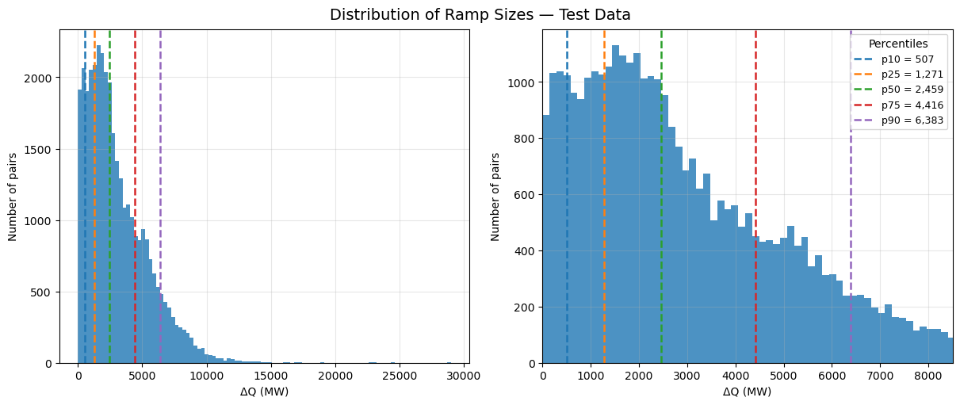

**Figure M3. Distribution of Ramp Sizes (∆Q in MW) in the Full Dataset**

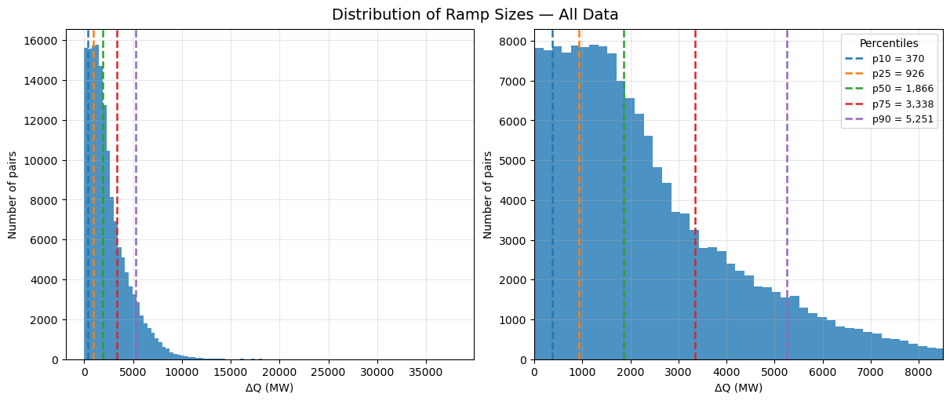

**Figure M4. Correlation Scores Relative to Ramp Pair Sizes (∆Q in MW) on Validation Dataset**



**Figure M5. Correlation Scores Relative to Ramp Pair Sizes (∆Q in MW) on Test Dataset**

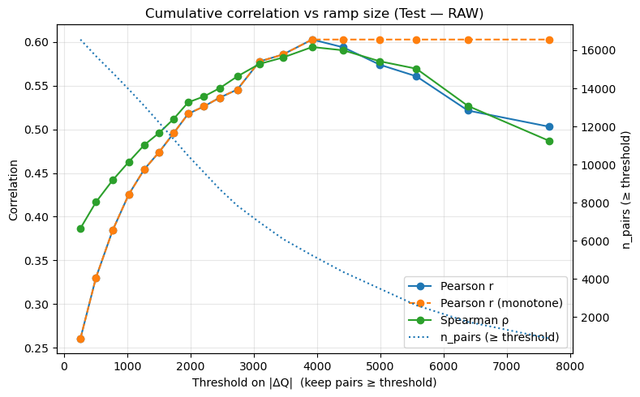

**Figure M6. Calibration at Ramp ∆Q = 4,255 MW for Validation Dataset**

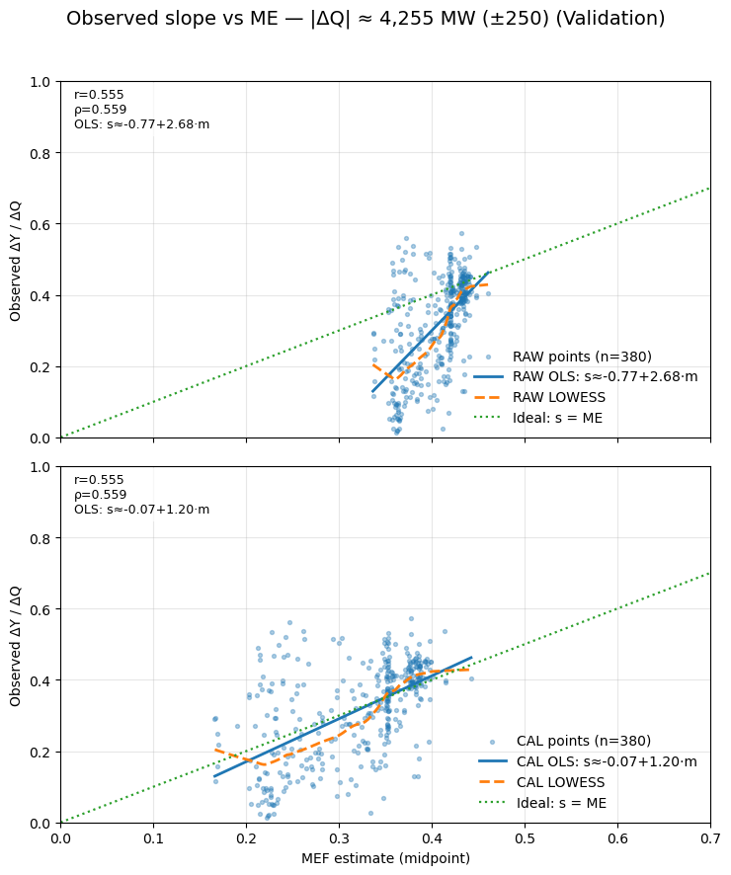

**Figure M7. Calibration at 50th percentile Ramp (∆Q in MW) for Validation Dataset**

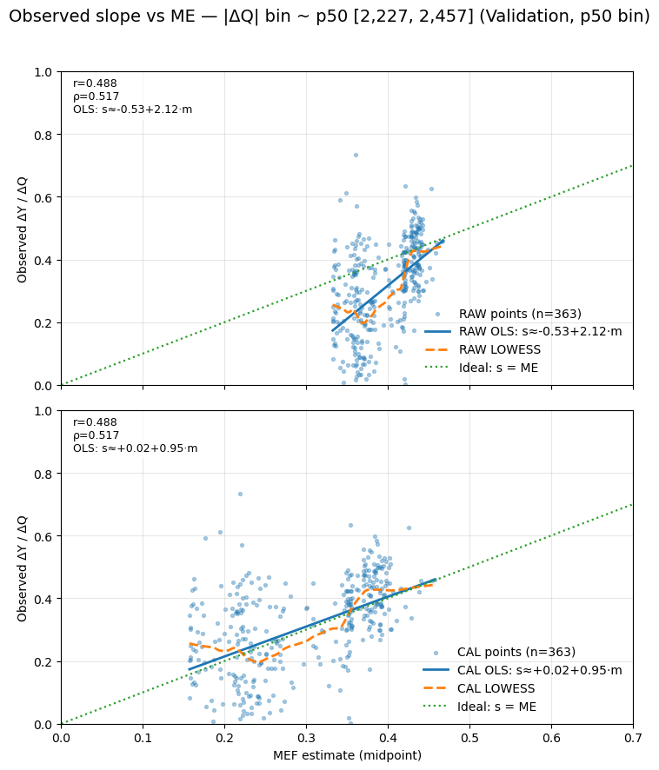

**Figure M8. Calibration at 50th percentile Ramp (∆Q in MW) for Test Dataset**

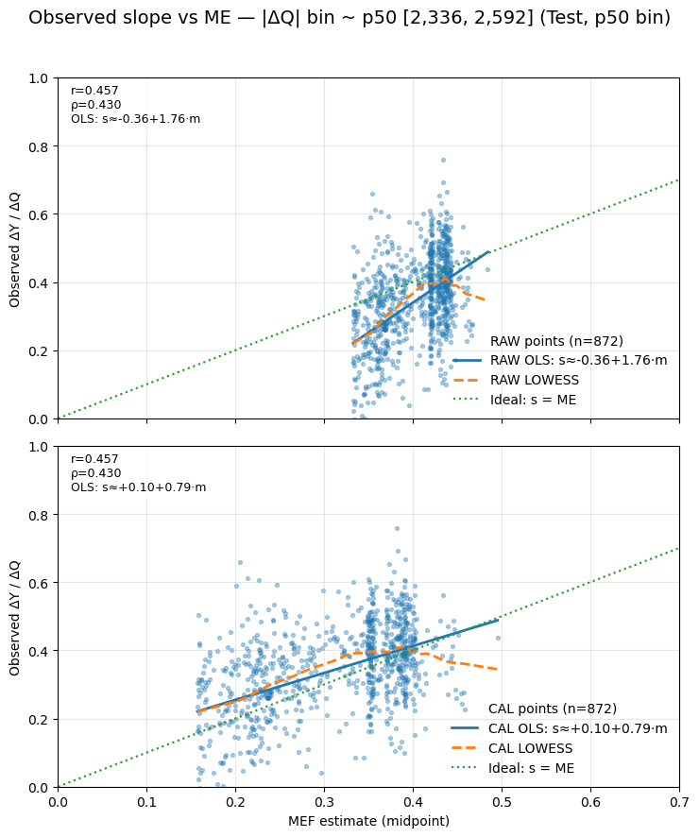

**Figure M9. Calibration at 10th, 50th, 90th percentile ramps (∆Q in MW) for Validation Dataset**

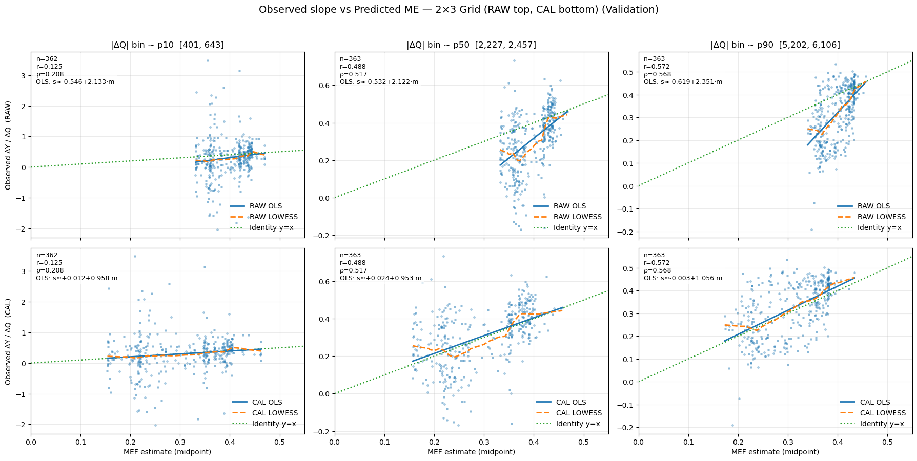

**Figure M10. Calibration at 10th, 50th, 90th percentile ramps (∆Q in MW) for Test Dataset**



**Figure M11. Hourly Average and Marginal Emission Factors by Estimation Method, 2024**

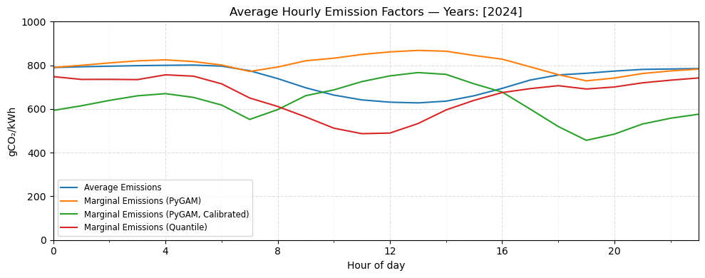

**Figure M12. Hourly Average and Marginal Emission Factors by Estimation Method (reduced), 2024**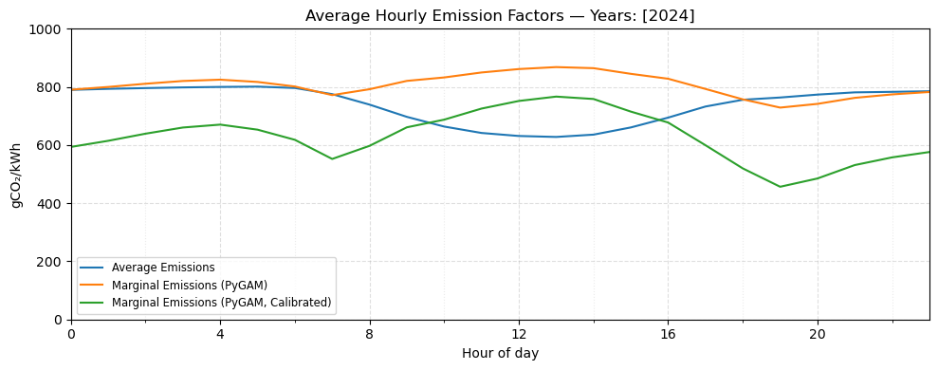

**Figure M13. Hourly Marginal (calibrated) and Average Emission Factors, 2022-2024**



**Figure M14. Distribution of Average and Marginal Emission Factor Values by Year**



**Figure M15. Marginal Emission Factor Estimate Confidence Label Counts by Year**

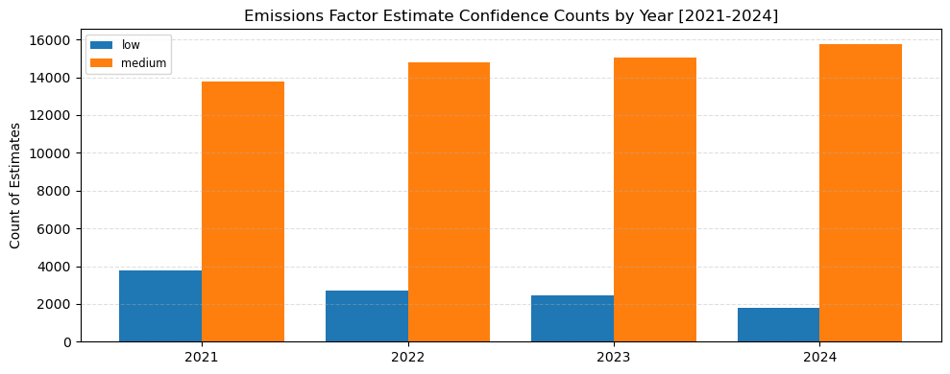

**Figure M16. Marginal Emission Factor Estimate Confidence Label Counts by Hour, 2024**

**Figure M17. Hourly Average and Marginal Emission Factors with Average Usage (kWh), 2023**

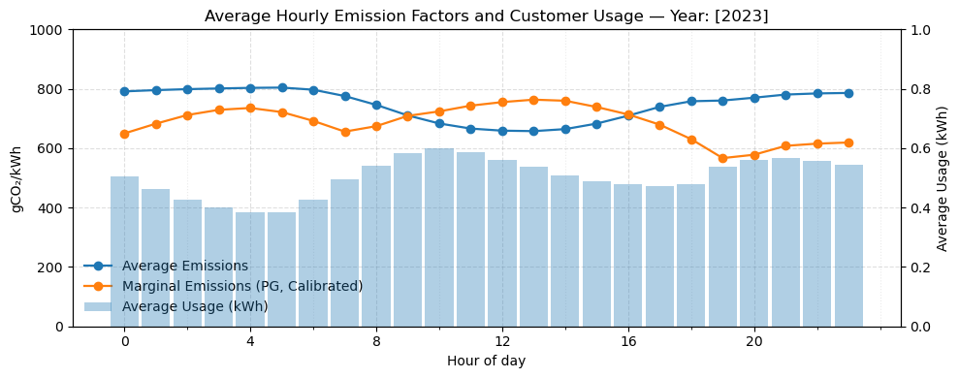

**Figure M18. Hourly Average and Marginal Emission Factors with Average Usage (kWh), 2022**

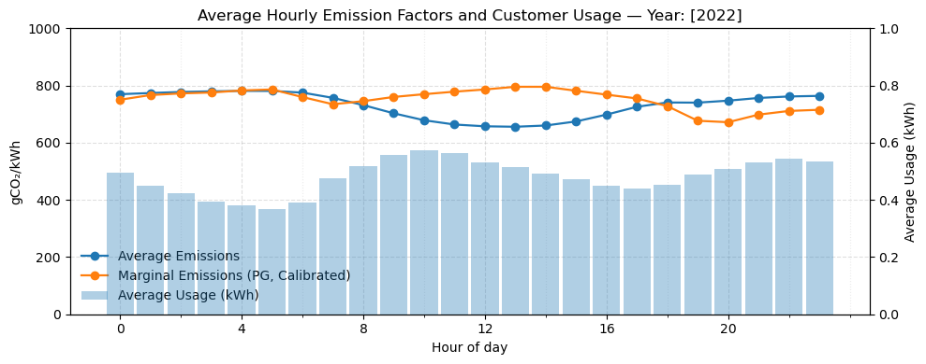

**Figure O1. Hourly Energy Profile pre- and post-Optimisation**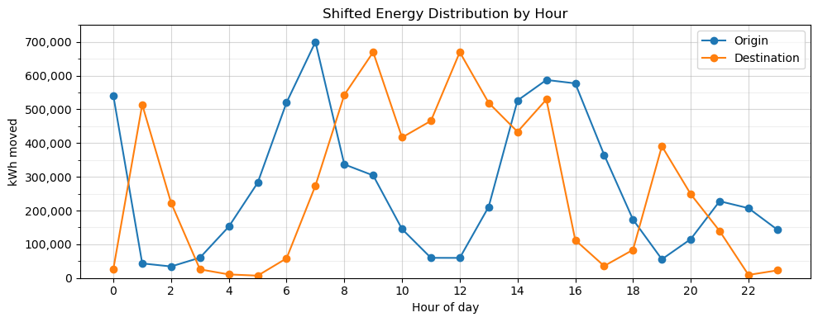

**Figure O2. Hourly Emissions Profile pre- and post-Optimisation, Average and Marginal Emissions**

**Figure O3. Distribution of Optimisation Shift Temporal Sizes**

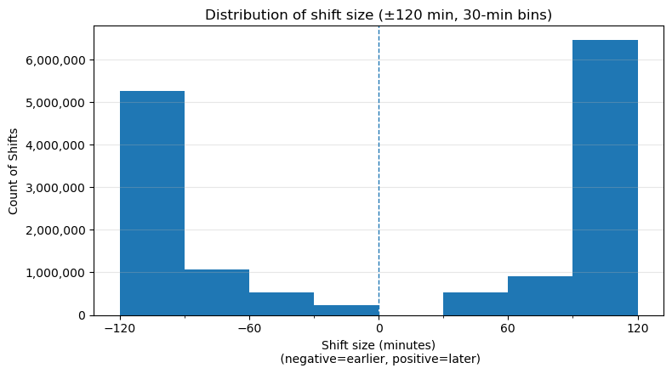

**Figure O4. Direction of Optimisation Shifts**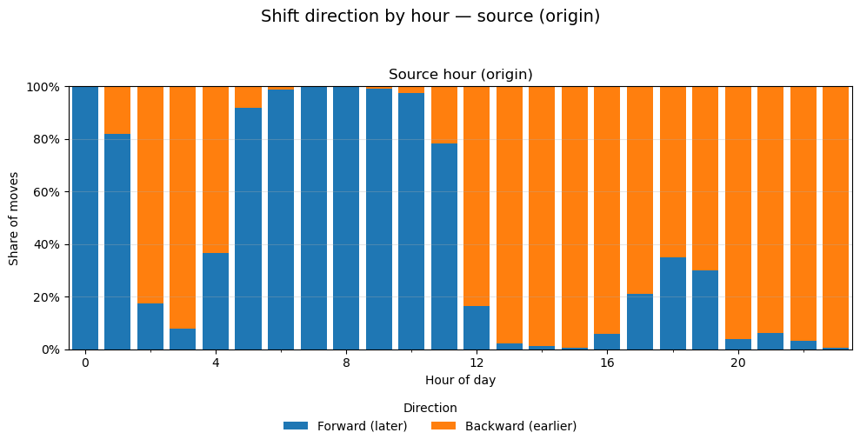

**Figure S1. Histogram Distribution of Energy Usage per Hour for all Customers (kWh)**

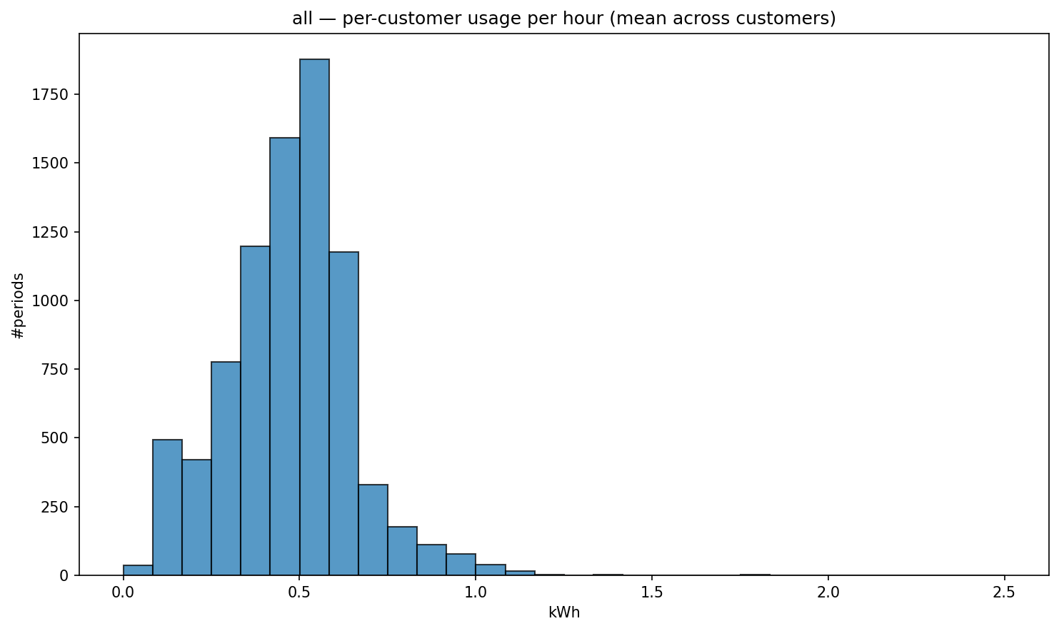

**Figure S2. Boxplot Distribution of Energy Usage per Hour for all Customers (kWh)**

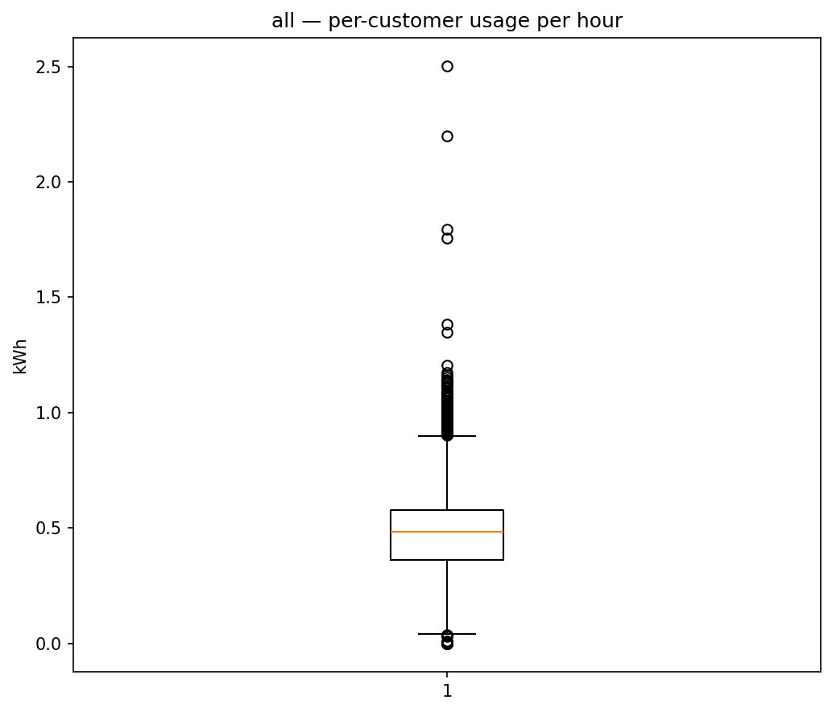

**Figure S3. Hourly Energy Use Profiles for Weekday v Weekend Patterns.**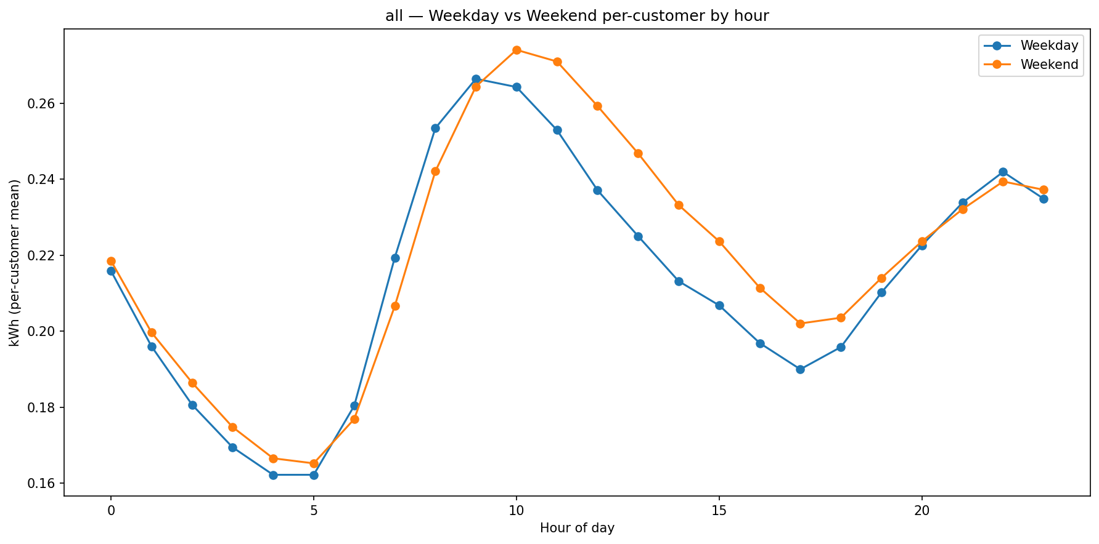

**Figure S4. Boxplot Distribution of Annual Energy Usage per Customer (kWh)**

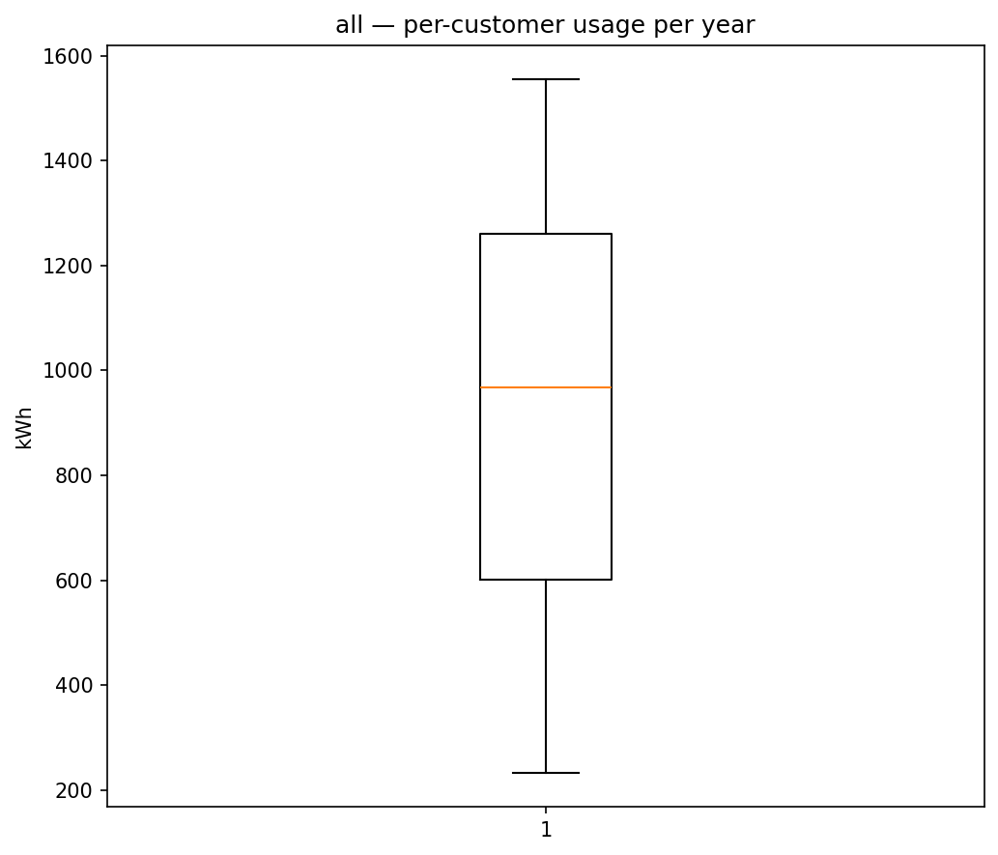

**Figure S5. Location of Customers in Delhi**

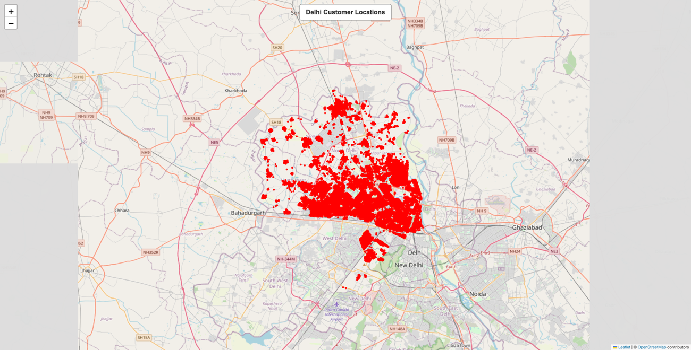

**Figure S6. Location of Customers in Mumbai**

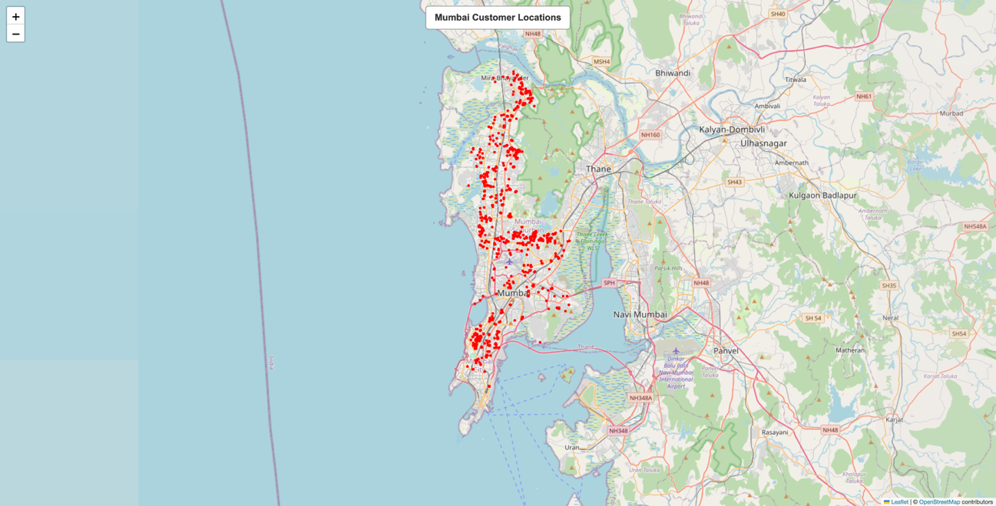

**Figure S7. Daily Usage Profiles by Hour, Mumbai**

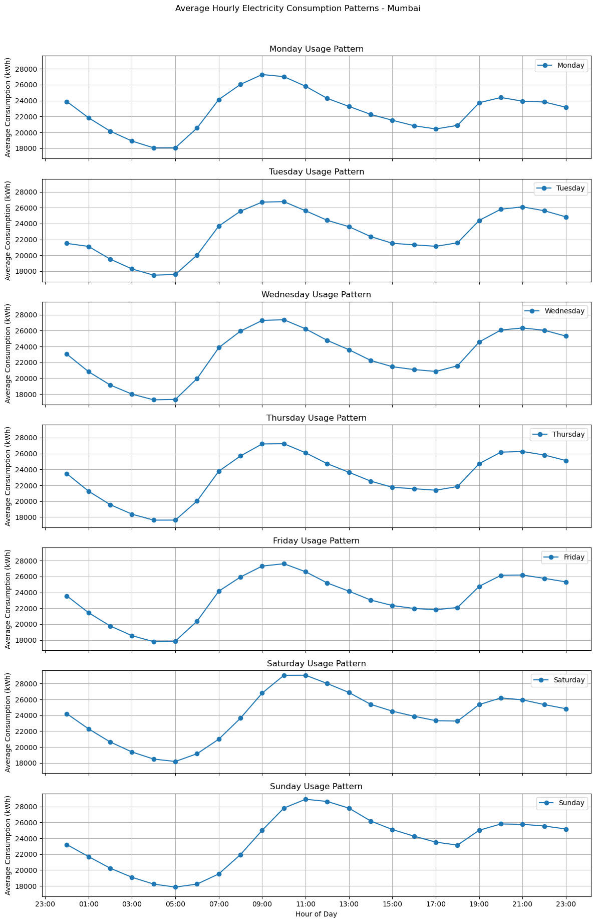

**Figure S8. Quarterly Generation Shares and Trends, 2020-2025**

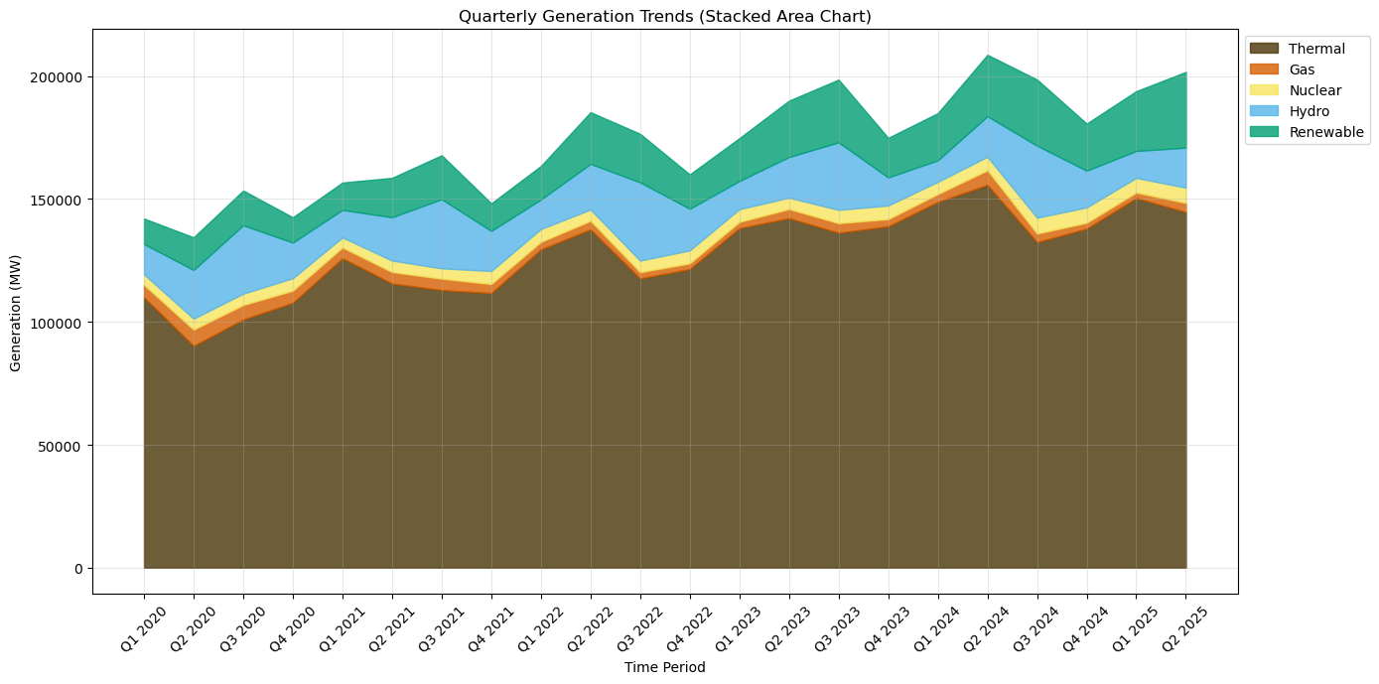

**Figure S9. Generation Share Growth Relative to 2021**

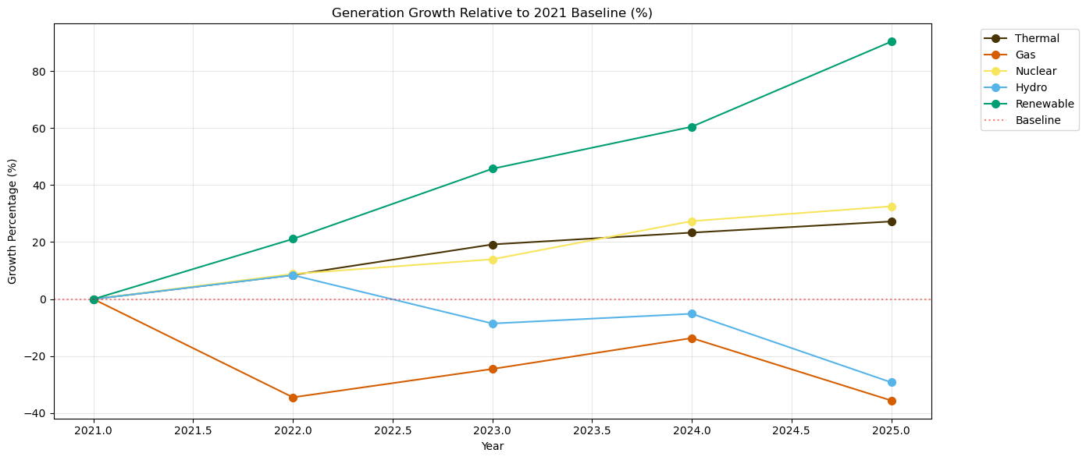

**Figure S10. Year over Year Growth of Generation Sources, 2021-2025**

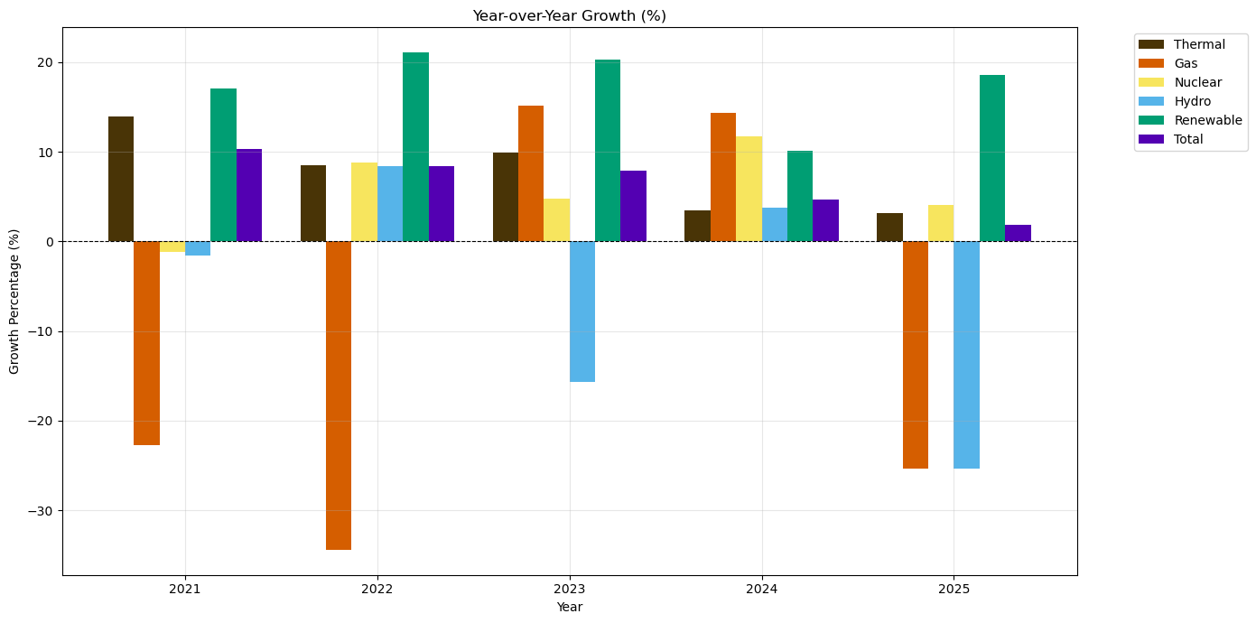

**Figure S11. Contribution of Generation Sources to Overall Growth, 2021 Baseline**

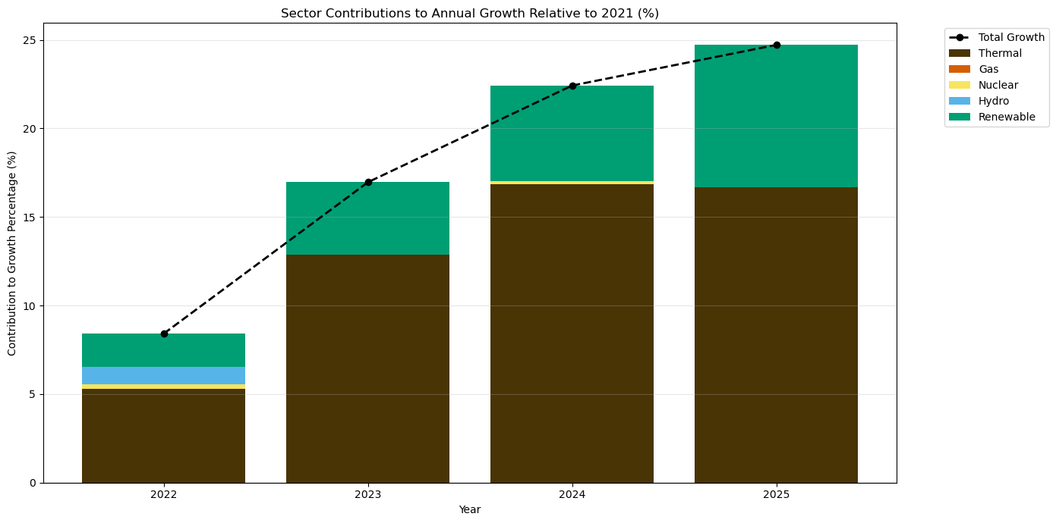

**Figure S12. Total Generation Daily Profile, 2022-04-01**

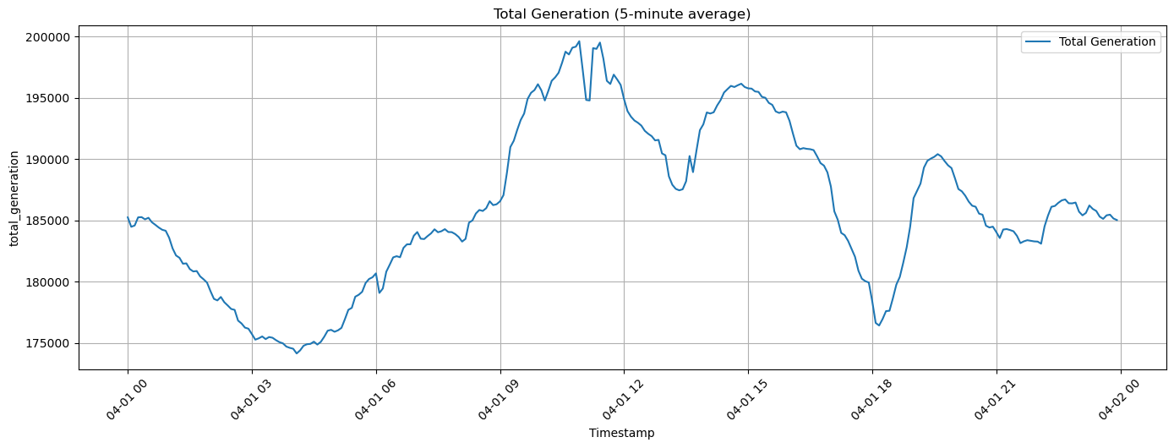

**Figure S13. Thermal Generation Daily Profile, 2022-04-01**

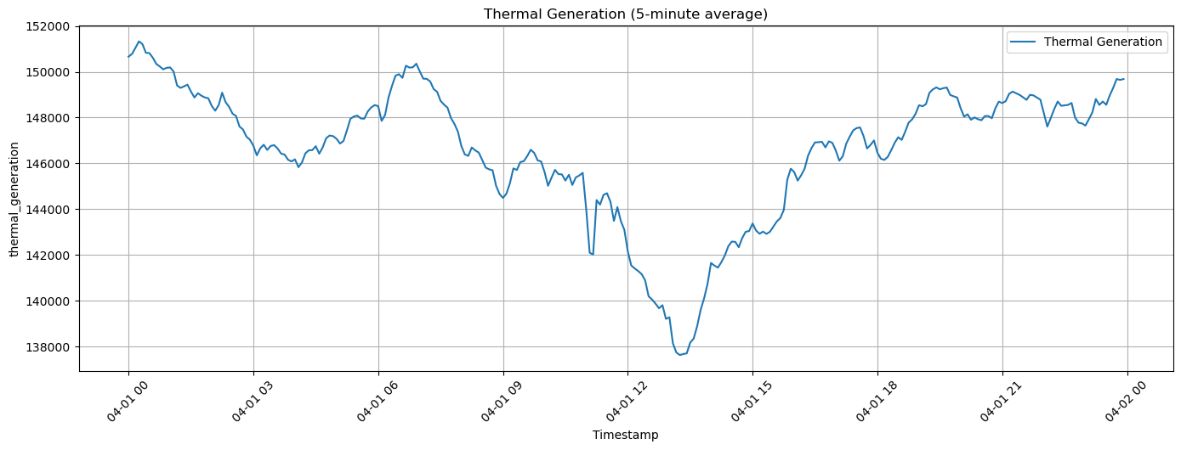

**Figure S14. Gas Generation Daily Profile, 2022-04-01**

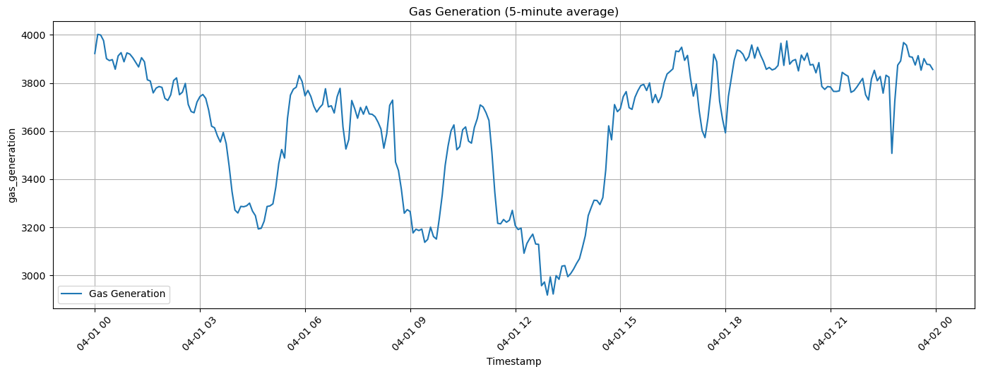

**Figure S15. Hydro Generation Daily Profile, 2022-04-01**

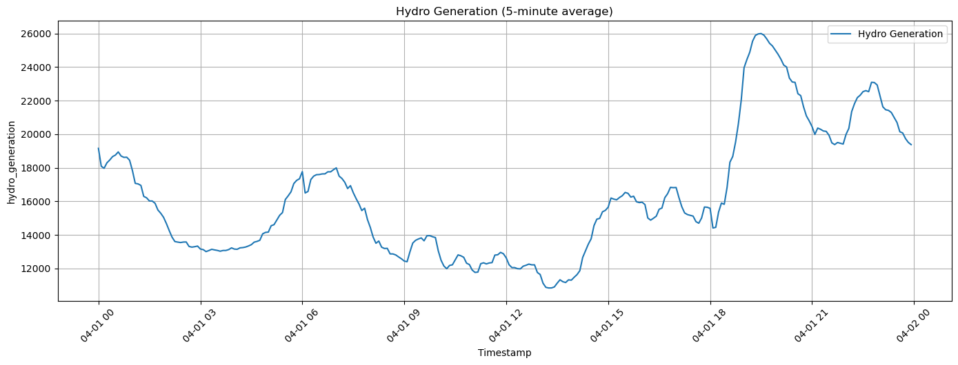

**Figure S16. Nuclear Generation Daily Profile, 2022-04-01**

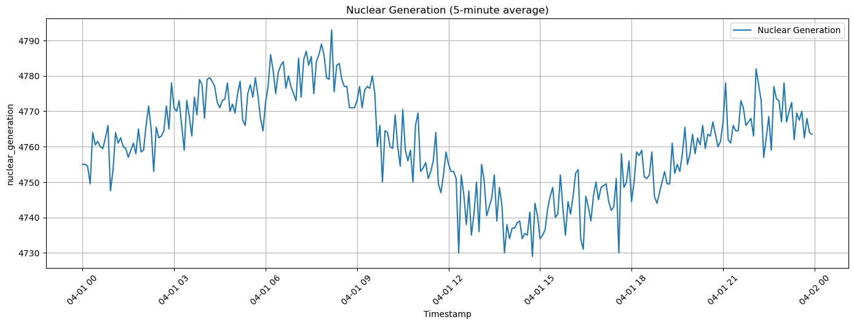

**Figure S17. Renewable Generation Daily Profile, 2022-04-01**

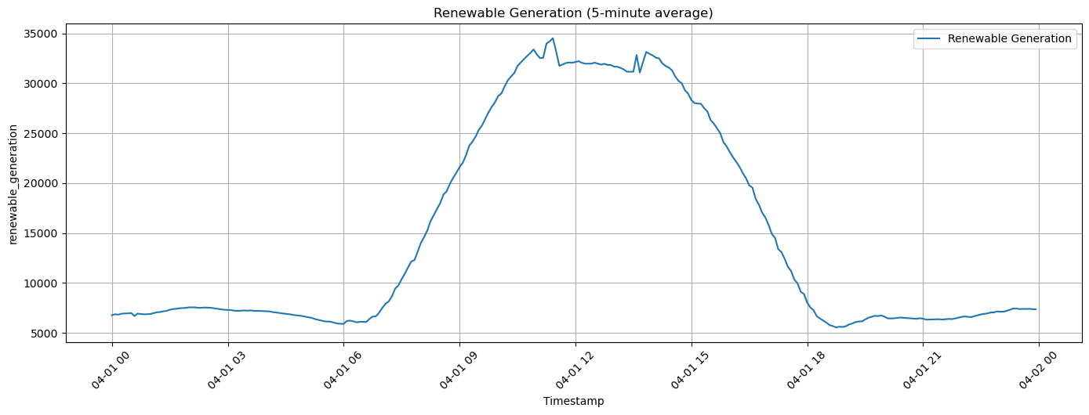

**Figure S18. Gap Filling Generation Data, 2020-03-24**

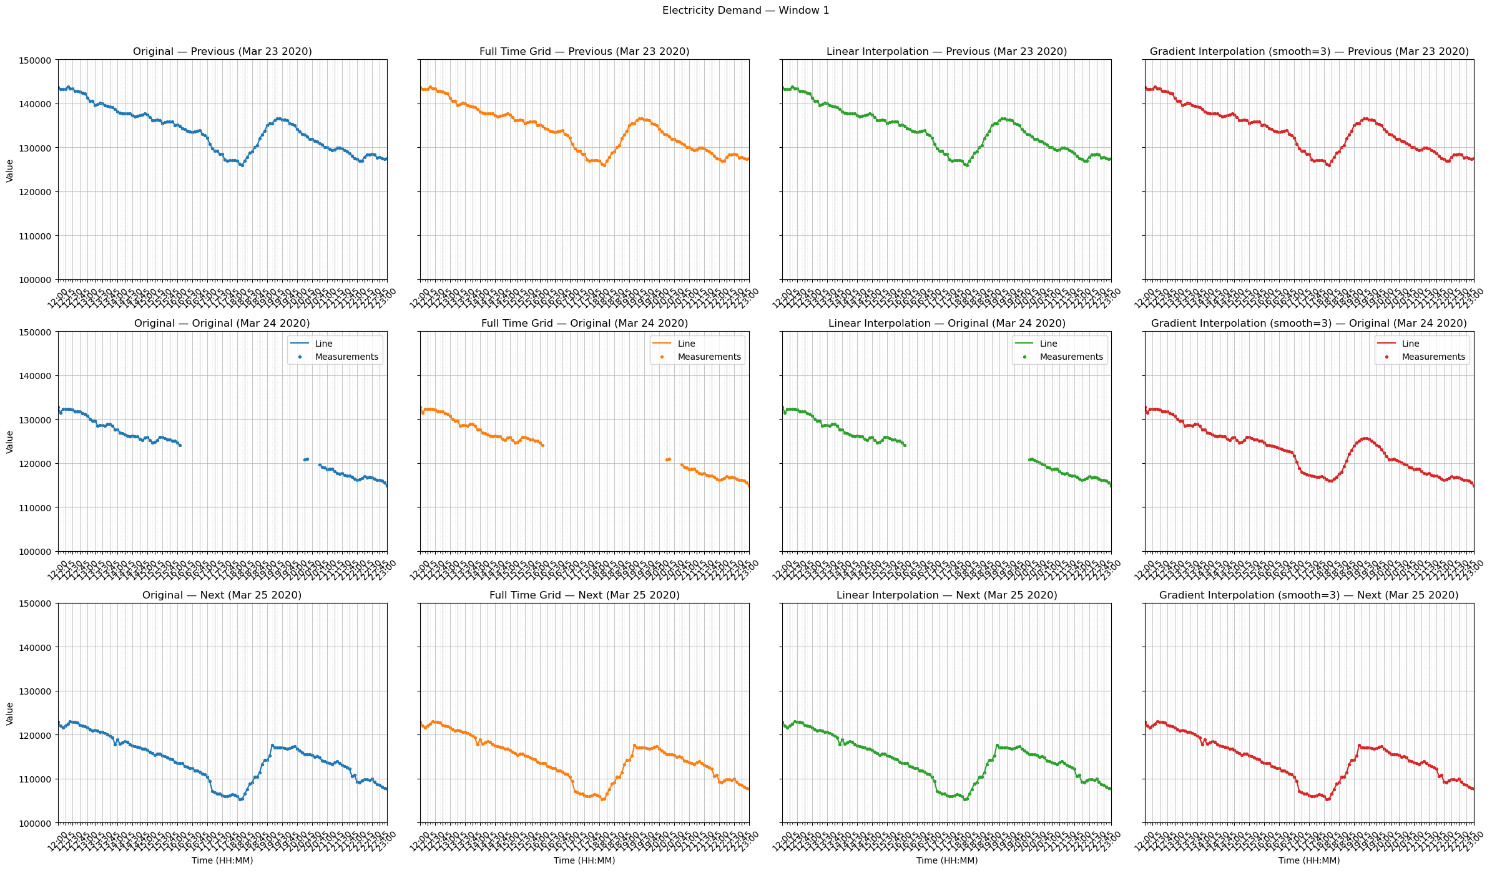

**Figure S19. Gap Filling Generation Data, 2022-04-25**

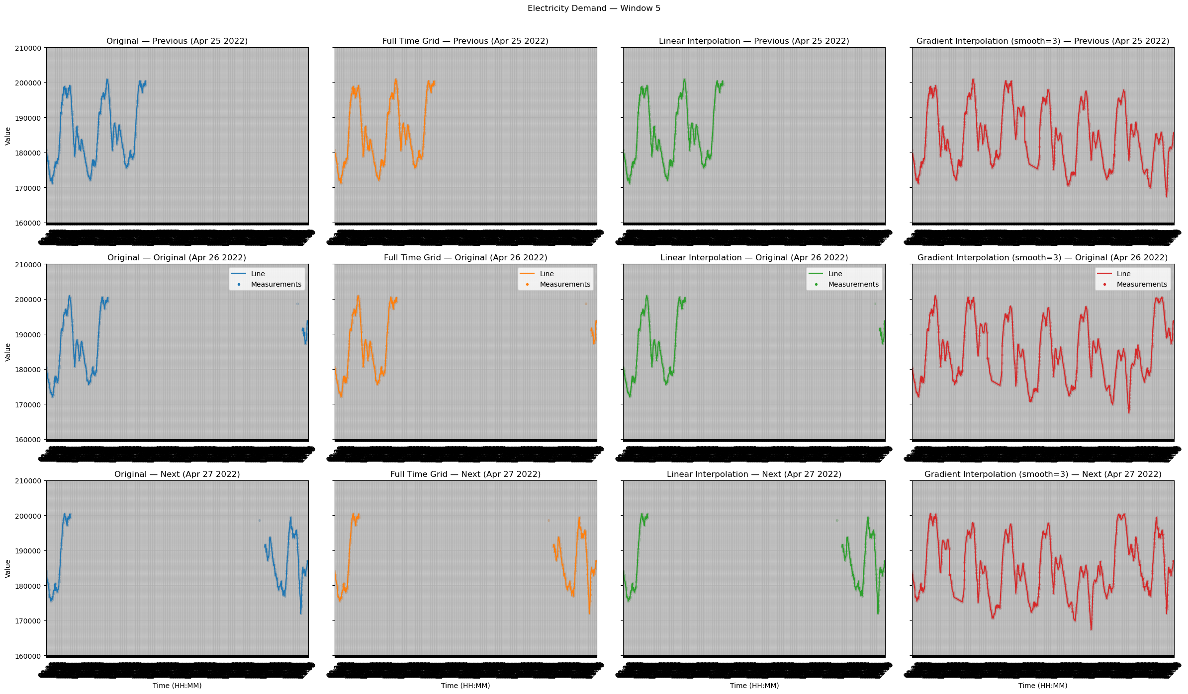

**Figure S20. Gap Filling Generation Data, 2024-04-05**

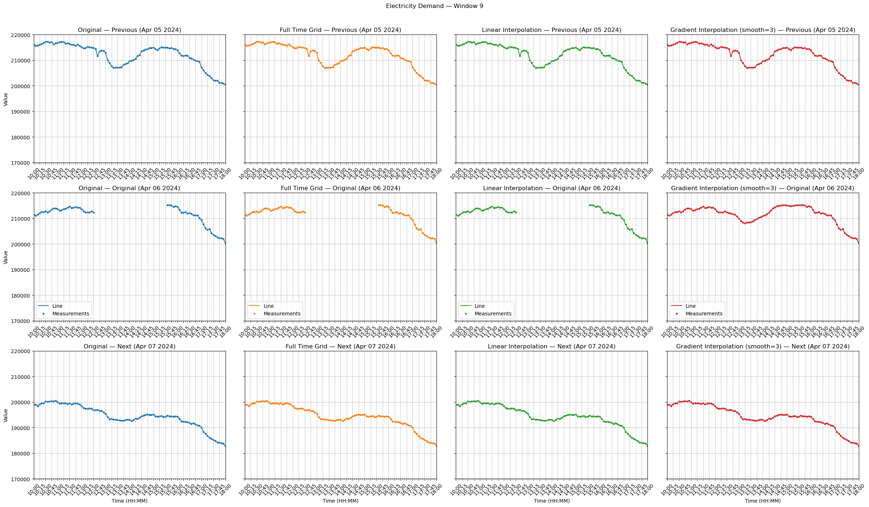

**Figure S21. Histogram Distributions of Generation Data**

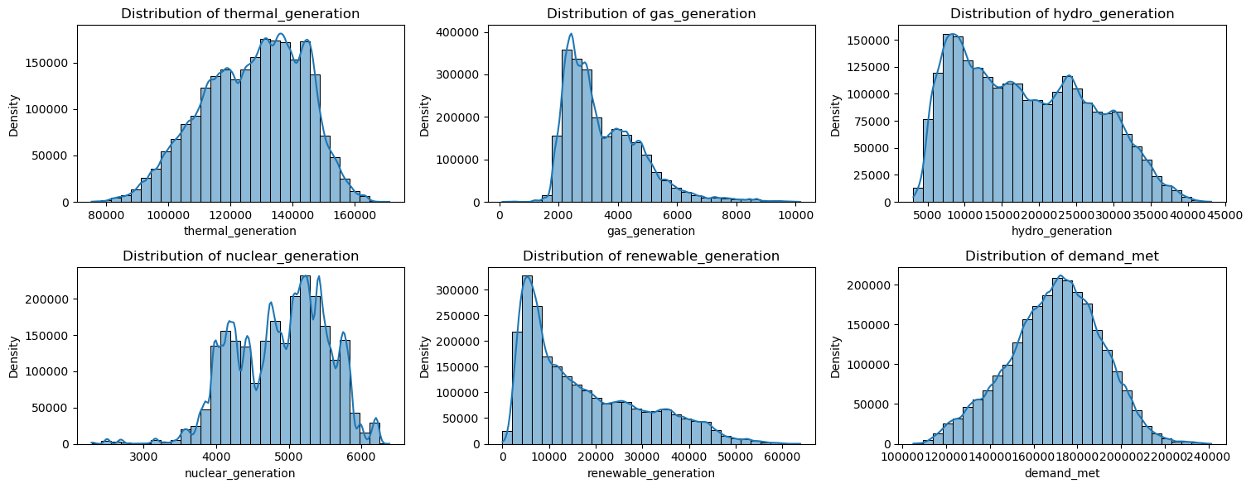

**Figure S22. Histogram Distributions of ERA5 weather data**

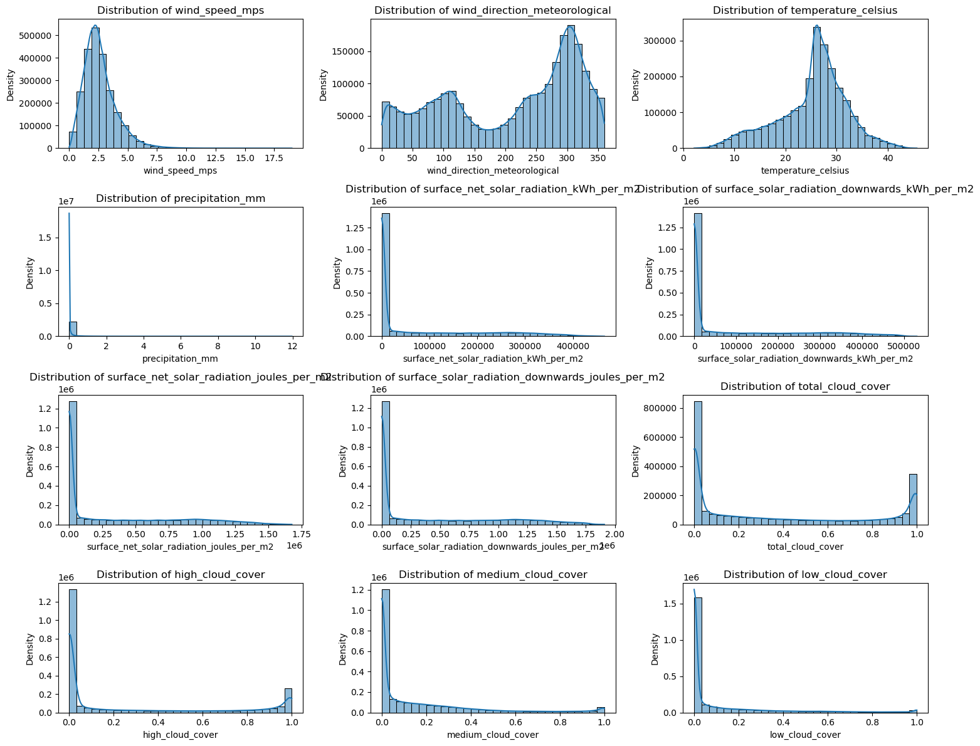

**Figure S23. Histogram Distribution of Tons of CO2 (Generation)**

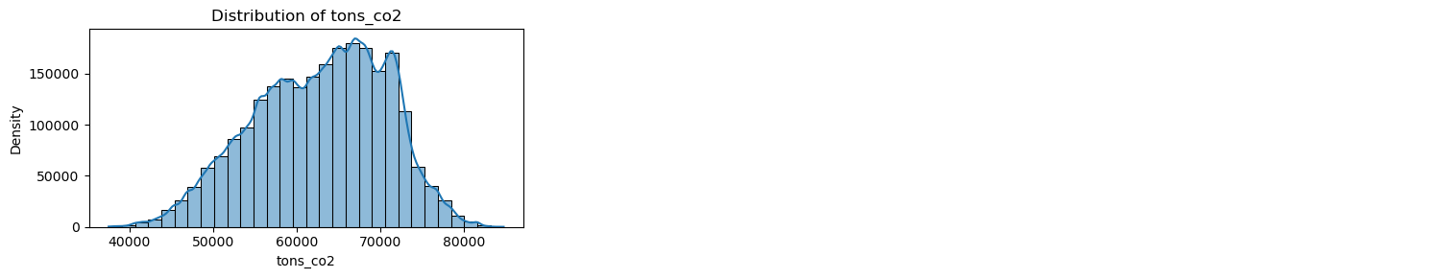

**Figure S24. Histogram Distribution of Wind Speed post Log-Transform**

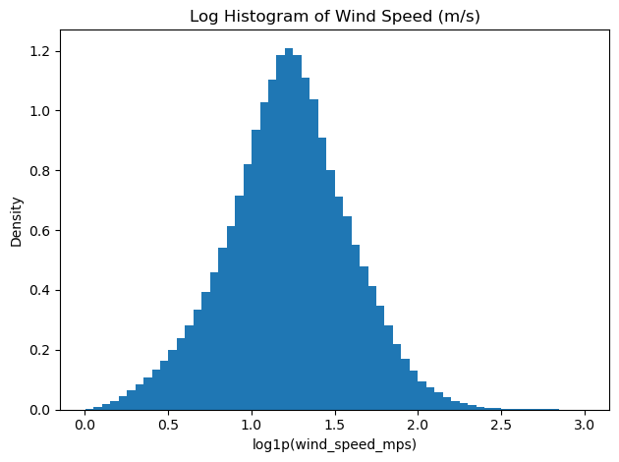

**Figure S25. Seasonal Patterns of Temperature – Average Daily Profile**

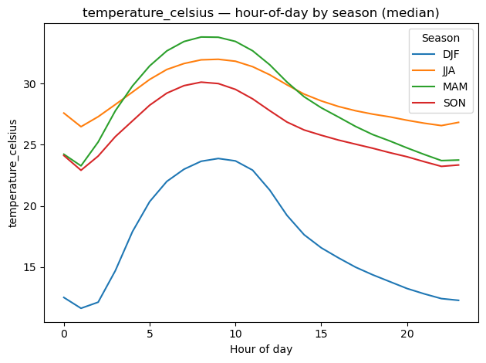

**Figure S26. Seasonal Patterns of Wind Speed – Average Daily Profile**

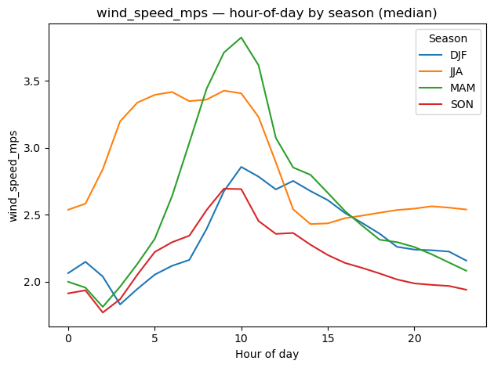

**Figure S27. Seasonal Patterns of Solar Radiation – Average Daily Profile**

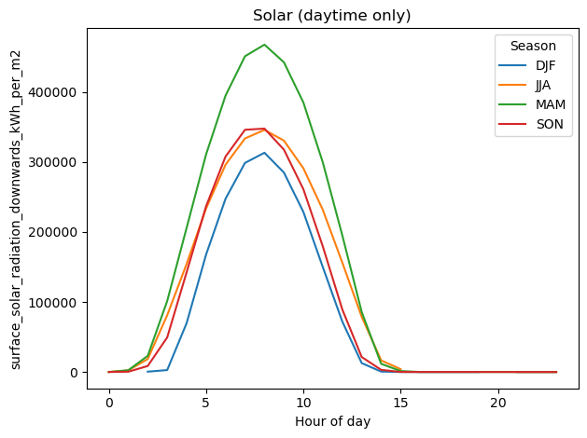

**Figure S28. Seasonal Patterns of Wind Direction – Average Daily Profile**

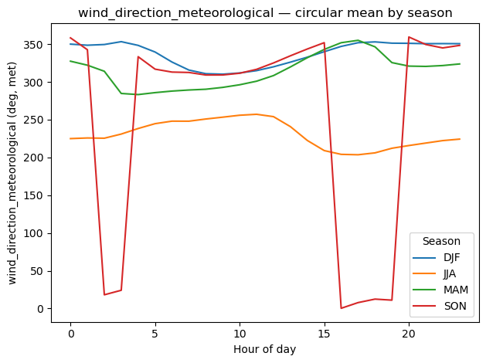

**Figure S29. Covariance Matrix of Core Predictor Variables (untransformed)**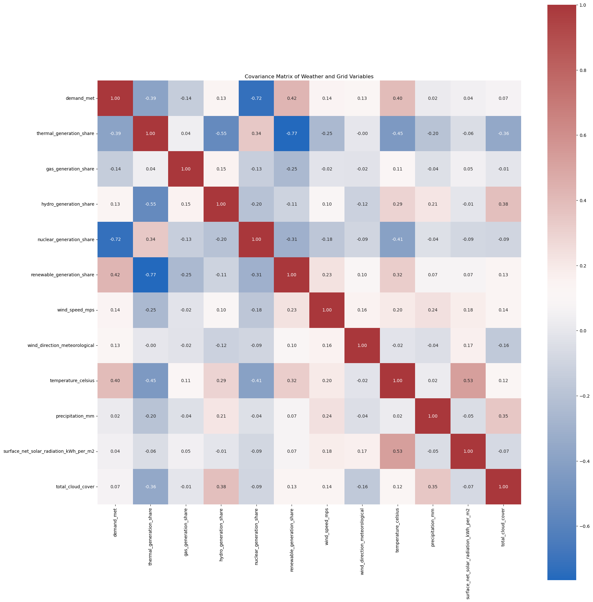

**Figure S30. Hitachi Database Schema**

